INTERSTATE TRAVEL PASSPORT

SYSTEM

NURUL AMIRA BINTI ANWAR

SESSION 2020/2021

FACULTY OF COMPUTING AND INFORMATICS

MULTIMEDIA UNIVERSITY

JUNE 2021

INTERSTATE TRAVEL PASSPORT

SYSTEM

BY

NURUL AMIRA BINTI ANWAR

SESSION

2020/2021

THIS PROJECT REPORT IS

PREPARED FOR

FACULTY OF COMPUTING AND INFORMATICS

MULTIMEDIA UNIVERSITY

IN PARTIAL FULFILLMENT

FOR

BACHELOR OF INFORMATION TECHNOLOGY

B.IT (HONS) INFORMATION SYSTEMS

FACULTY OF COMPUTING AND INFORMATICS

MULTIMEDIA UNIVERSITY

JUNE 2021

Copyright of this report belongs to Universiti Telekom Sdn. Bhd. as qualified by Regulation 7.2 (c) of the Multimedia University Intellectual Property and Commercialisation Policy. No part of this publication may be reproduced, stored in or introduced into a retrieval system, or transmitted in any form or by any means (electronic, mechanical, photocopying, recording, or otherwise), or for any purpose, without the express written permission of Universiti Telekom Sdn. Bhd. Due acknowledgement shall always be made of the use of any material contained in, or derived from, this report.

© 2020 Universiti Telekom Sdn. Bhd. ALL RIGHTS RESERVED.

DECLARATION

I hereby declare that the work has been done by myself and no portion of the work contained in this thesis has been submitted in support of any application for any other degree or qualification of this or any other university or institute of learning.

_______________________

NURUL AMIRA BINTI ANWAR

Faculty of Computing & Informatics

Multimedia University

Date: 08/06/2021

# ACKNOWLEDGEMENT

Firstly, all praise is due to the Almighty Allah S.W.T for His blessings and for providing me with the strength to successfully complete this final year project. I would like to express my heartfelt appreciation to my supervisor, Dr. Wan Noorshahida for her continuous guidance and comments in every part of this project. Dr. Shahida gave a lot of suggestion and tips for proper way to present a better report. Apart from that, she is also a kind and understanding supervisor when I had a problem.

Last but not least, I am grateful to my family and friends for their unwavering support and prayers. Without their support, I would not be able to finish this project. During this hard time, their encouragement are much needed and it was a relief when they care for me. Thank you.

# ABSTRACT

The rapidly increasing positive Covid 19 cases are quite worrying and as an initiative, the government has announced the partial lockdown which include the prohibition of interstate travel. However, there are several individuals who are permitted to cross the state with the requirement that they receive approval from the police station with valid reasons. As for now, the applicant need to go to the police station to get the permit form and fill in the details along with the supporting documents. This lead to result a long queue and the applicant had to waste their time as well as exposed to the virus for a long time. The Interstate Travel Passport System is develop so the applicant can request the permit and fill in the details with supporting documents online before going to the chosen police station for approval. After the administrator officer check and approved, they will generate a QR Code and the status for the applicant will change from “PENDING” to “APPROVED”. With this system, it can also avoid fraud at the roadblock location because the applicant still need to go to the police station to get the QR Code and change of status. This system also ease the applicants and the roadblock officer by clearing the traffics because the officer just need to scan the QR code to view the applicant status and details. The applicants and the roadblock officer will use mobile-based while the administrator officer use web-based for a smooth process.

Contents

ACKNOWLEDGEMENT

ABSTRACT

Chapter 1 : INTRODUCTION 1

1.1 Problem Statement 1

Project Objectives 3

Project Scope 4

Report Organization 6

Chapter 2 : BACKGROUND STUDY 7

2.1 Existing Systems 7

2.1.1 Manual 7

2.1.2 Bantuan Prihatin Rakyat 9

2.1.2 MySejahtera 11

2.1.2 MMU Mobile 14

2.1.2 Gerak Malaysia 16

2.2 Comparison 17

Chapter 3 : REQUIREMENTS 19

System Overview 19

System Requirement 20

3.2.1 Software 20

3.2.2 Hardware 21

Functional Requirement 22

3.3.1 Use Case Diagram 22

3.3.2 Software Requirement Specifications (SRS) 23

3.3.3 Context Diagram 32

3.3.4 Data Flow Diagram 33

3.4 Non Functional Requirement 36

Chapter 4 : DESIGN 37

4.1 Sequence Diagrams 37

4.1.1 Permit Applicants 37

4.1.2 Roadblock Officer 38

4.1.3 Administrator Officer 39

4.2 Prototype 40

4.2.1 Mobile-based Application for Permit Applicants 40

4.2.2 Mobile-based Application for Roadblock Officer 43

4.2.3 Web-based Application for Administrator Officer 46

Chapter 5 : Implementation Plan 49

5.1 FYP 1 49

5.2 FYP 2 49

Chapter 6 : Conclusion 50

6.1 Conclusion 50

6.2 Obstacles 51

6.3 Future work 51

References 52

Appendix A : FYP 1 Meeting Logs 53

APPENDIX B : Turnitin Report 54

# List Of Tables

Table 2.1 Comparison between existing applications ………………………………………. 30

Table 3.1 Use Case 1 ……………………………………………………………………...… 35

Table 3.2 Use Case 2 ……………………………………………………………………...… 36

Table 3.3 Use Case 3 ………………………………………………………………………... 37

Table 3.4 Use Case 4 ………………………………………………………………………... 38

Table 3.5 Use Case 5 ………………………………………………………………………... 39

Table 3.6 Use Case 6 ………………………………………………………………………... 40

Table 3.7 Use Case 7 ………………………………………………………………………... 41

Table 3.8 Use Case 8 …………………………………………………………………...…… 42

Table 3.9 Use Case 9 ………………………………………………………………………... 43

Table 5.1 Gantt Chart FYP 1 ……………………………………………………………….. 61

Table 5.2 Gantt Chart FYP 2 ……………………………………………………………..… 61

# List Of Figures

Figure 2.1 Interstate Travel Permit Form ……………………………………………...……. 19

Figure 2.2 Bantuan Prihatin Rakyat …………………………………………………...……. 21

Figure 2.3 MySejahtera ………………………………………………………………...…… 23

Figure 2.4 MMU Mobile ……………………………………………………………...…….. 26

Figure 2.5 Gerak Malaysia ………………………………………………………………….. 28

Figure 3.1 System Overview ………………………………………...……………………… 31

Figure 3.2 Use Case Diagram ………………………………………………………………. 34

Figure 3.3 Context Diagram ………………………………………...………………………. 44

Figure 3.4 DFD Permit Applicants ………………………………………...……………….. 45

Figure 3.5 DFD Enforcement Officer …………………………………………...………….. 46

Figure 3.6 DFD Document Administrator ………………………………………………….. 47

Figure 4.1 Sequence Diagram Permit Applicant …………………………………………… 49

Figure 4.2 Sequence Diagram Enforcement Officer ……………………………..…………. 50

Figure 4.3 Sequence Diagram Document Officer ……………………………...…………… 51

Figure 4.4 Splash Screen and Login ……………………………………………………...… 52

Figure 4.5 Profile and Sign Up ……………………………...……………………………… 52

Figure 4.6 Dashboard and Profile …………………………………………………….…….. 53

Figure 4.7 Permit ……………………………………………………………………………. 54

Figure 4.8 Status for APPROVED and PENDING ………………………………..……….. 54

Figure 4.9 Sign In and Dashboard ………………………………………………………….. 55

Figure 4.10 Profile and Edit profile ………………………………….……..………………. 56

Figure 4.11 Approved and Rejected screen ………………………………………………… 56

Figure 4.12 Scan and Permit details ………………………………………………………… 57

Figure 4.13 Dashboard and Profile …………………………………………………….…… 58

Figure 4.14 Applicant List ………………………………………………………………….. 58

Figure 4.15 Review and Generate QR code ……………………………...…………………. 59

Figure 4.16 Rejected Reasons ……………………………………………………….……… 60

Figure 4.17 Statistics …………………………………………………………………..……. 60

# Chapter 1 : INTRODUCTION

## 1.1 Problem Statement

The government has announced the Movement Control Order (MCO) for 3 times which prohibits recreational and religious activities, closes all schools and universities, allows only essential services to operate and restricts interstate travel. The police along with soldiers are stationed at designated location to man roadblocks. They will check the travel permit and other documents and will only allow the person to continue their journey if the permit was signed and stamped from a police station. The process of crossing the state should be simple and uncomplicated with the mobile application for the applicants to apply for a permit.

Based on mysumber, on April 26th 2020, an application called "Gerak Malaysia" was developed by PDRM and MCMC with support by a telecommunication company. The application are primarily for individuals or families who have become stranded in the village and wish to return home. (mysumber, 2020)

However, according to NST, the application was discontinued on July 31st 2020 due to the uplift of the first MCO so the application was no longer required. The PDRM and MCMC also advised users to uninstall because it would be deactivated and all of their personal information would be sent to Health Ministry (NST, 2020)

Because the application only lasted a few months, once the second MCO was announced, the process for obtaining an interstate travel permit reverted to manual. The issue with using the permit manually is that some people abuse it by signing and stamping it without approval from the police station. There are also people who took the

clean, signed and stamped permit and printed a large number of copies to sell at a high price. This case has tarnished the PDRM's reputation while also rendering the MCO ineffective because they did not stay at home and break the rules. A few people even shared a picture of the permit on the social media platform Twitter. This proposed system can prevent fraud because they must go to the police station to obtain the approval status and a QR code.

Next, while the majority of the sectors is required to work from home, there are a few sectors that require employees to physically go to work, such as essential service workers and front liners. Because the police had to thoroughly check their permit and other supporting details at the roadblock, the traffic jammed took a long time, even up to 2 hours. This enraged many employees, particularly the front liners.

Last but not least, in order to obtain approval from the police station, everyone must wait in a long line just to get the permit, which requires a lot of time just to fill out. Some people who are unfamiliar with the process to apply an interstate travel permit will go blank because they did not prepare any supporting documentation and will have to return to retrieve the documents.

## Project Objectives

1. To explore and study the requirements of Workflow Management System.
2. To investigate the existing systems related to Workflow Management System.
3. To design and develop an end to end system for Interstate Travel process.

I can gain a better understanding of Workflow Management System by finding a lot of information about it through article research, websites, and past research. Business operations that are trying to remove problems such as excessive paper usage and manual processes tend to use the system to manage, track and optimise workflows. The benefits of automated workflow include time savings and increased efficiency. Nowadays, technology has advanced to low-code platforms that allow non-technical users to develop any application with the related system.

Next, by observing the features of existing systems, we can improve the proposed solution by determining which category is appropriate for workflow systems. Most existing systems include features such as a process builder, reporting tools, and an engine. We can also see the benefits and drawbacks of WMS in comparison to other applications. Aside from boosting internal processes, it can also reduce fraud and bias caused by improperly approving a request. However, most applications failed to meet user expectations when they were not prepared with workflow management, resulting in poor performance and reliability.

Last but not least, after proper study of current trends and technology, we can develop a mobile-based application that both the roadblock officer and the applicant can use to aid them in the interstate travel process. While the administrator officer will manage the process using a web-based application. When a user signs in, the interface will be based on their roles.

## Project Scope

Interstate Travel Passport System is a system that uses the Workflow Management System concept and is intended for use by applicants and police officers via mobile and web-based applications. The users can use the mobile application if they have a smartphone that supports Android OS. They can create an account and sign in using their username and password.

The applicants can choose from 3 options which is Profile, Request, or Status. They can view their profile on the profile page, which includes information such as their name, IC number, address, email, and phone number. They can also edit their address, email, profile picture and phone number. As for the request button, they can use it to apply for an interstate travel permit. They must fill out the form with their name, IC number, citizenship, car type, registration plate, travel reasons, departure and return date. Applicants must also select a police station and upload supporting documents such as an IC copy, an approval letter, a road tax, and any other supporting documents that are available. After submitting the request, they can check at the Status button for their status that will appear PENDING until they go to the police station to get approval, at which point the status will changed to APPROVED and they will receive a QR code.

The police force is divided into two roles: roadblock officer and administrator officer. However, for roadblock purposes, they have to use a mobile-based application, whereas a web-based application is only available to administrators. The roadblock officer can scan the QR code on the applicant's phone to see if they are APPROVED and view their details, including any supporting documents they have uploaded. While the administrator officer has access to the list of applicants who have requested an interstate travel permit, they will only approve and generate the QR code when the applicant arrive at the police station. They can also view the applicant's status as well as the QR code. Aside from that, they can also see the statistics of approved and rejected applicants.

## Report Organization

The goal of the project is to develop a system that will make the interstate travel process easier for both applicants and police. This project is explained in 6 chapters from beginning to end. The first chapter introduces the overview description, which includes the problem statement, objectives and scope.

Next, in Chapter 2, I perform background study by identifying similar systems to compare in order to develop a better system for this project. The advantages and disadvantages of each system are observed in order to gain an understanding of what Workflow Management System is all about.

As for Chapter 3, it explained in greater depth and detail because it includes both functional and non-functional requirements such as the hardware and software used. To demonstrate how this system works, technical drawings are used.

Chapter 4 mostly covered the sequence diagram and converting the technical diagram into a prototype, while Chapter 5 is for the implementation plan, where the timeline for FYP 2 is shown in a Gantt chart to ensure the quality of the project.

Lastly, the conclusion is in Chapter 6, where it summarizes the project and what obstacles were encountered, as well as future work where what can be upgraded for my future plan.

# Chapter 2 : BACKGROUND STUDY

## 2.1 Existing Systems

### 2.1.1 Manual

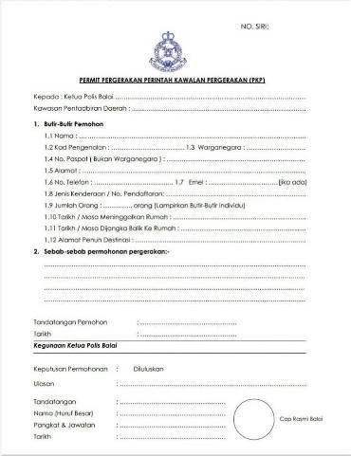

*Figure 2.1 Interstate Travel Permit Form*

Currently, the process to cross the state are by manually obtaining sign and stamped by police station at the permit form. To get the approval, applicants need to bring the form and supporting documents. This process way is not suitable due to the pandemic situation where we should restrain from staying outdoors for a long time.

Advantages

* No devices required

Since only paperwork are used, applicants did not have to bring any smartphone. They will also not encounter any problems if the smartphone is out of battery or did not get any connection.

Disadvantages

* Time consuming

The applicants have to queue for a long time at the police station because they need to fill out the form. They will also be stuck in traffic jammed due to roadblock when the officer need to check their permit form as well as the supporting documents.

* Inconvenience

Applicants need to bring supporting documents such as IC copy, supporting letter and road tax which makes it troublesome with a lot of paper to bring.

* Low security

Roadblock officer can be scammed by people who fake the signature and stamp from a police station because they cannot verify since it is manually.

### 2.1.2 Bantuan Prihatin Rakyat

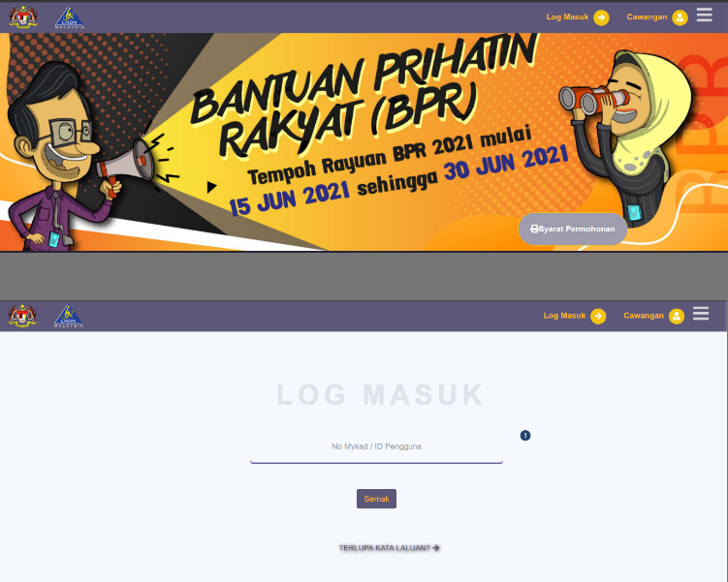

*Figure 2.2 Bantuan Prihatin Rakyat*

BPR is an application for B40 and M40 group to apply for a financial support that is develop by LHDN. This system replace the old version which is BSH with upgrade of increase in cash allocation. BPR helps household or singles depending on their income and total of kids.

Advantages

* View status of approval

User can check their status of approval at the profile page to see if they received the financial help. If the status are denied, BPR system also include the reason of why it got denied.

* High security

The system are secured because before logging into the dashboard, the user have to fill in the username and password as well as the security keywords.

* User friendly UI

The interface is very simple and easy to use since it is not packed in one page.

* Download & Upload features

The system include the download features where user can download the form and profile page. User can upload their supporting documents such as marriage certificate, divorce or death certificate and bank statement during signing up to provide proof.

Disadvantages

* Long waiting time

After user has sign up by filling in the form and providing documents if available, they will have to wait until a few month to see their status of approval.

* No notification

They did not provide any notification regarding the status because they will only announce the date of each phase.

### 2.1.2 MySejahtera

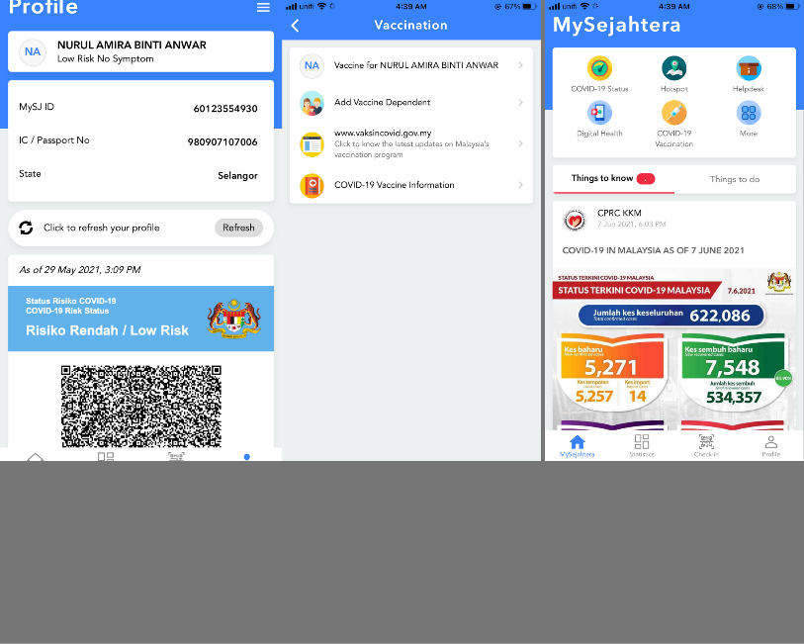

*Figure 2.3 MySejahtera*

Based on MySejahtera website, the application by the Malaysian government is to facilitate in controlling the COVID-19 pandemic. (MySejahtera, 2021)

All citizens in Malaysia are advised to install the application as it is being use for contact tracing at every entrance location including public transport. The failure of scanning the QR code when entering any premises will resulted to get compound by the police.

Advantages

* Tracking system features

MySejahtera can track Covid19 hotspot with the GPS tracking devices that can work when the user allow it to share their current location. Users can view how many positive cases within the radius of 1km.

* View statistics

The application provides statistic for the Covid 19 update weekly. The statistics that the user can view is the total confirmed case, total recovered case, total death and active case. Other than that, they also provide statistics with cases by states in Malaysia and global.

* Health Risk features

The user health risk can be detected through this application at risk status in the profile page. The status will be check by a guard before the user can scan the QR code to enter the premises. Only user with low risk, casual contact with or without symptom are allowed to scan and enter. If their risk status are confirm case with symptom, suspected case, close contact and person under surveillance, the are prohibited not only to scan but even going out of their quarantine area. The health risk features also provide a QR code.

* Scan features

The user must use the application to scan the QR code that are on display at every checkpoint usually at the entrance of any premises. The point for user to scan is so the Health Ministry can trace user’s journey. User can also add dependent after fill in a form about the dependent and can scan for both.

Disadvantages

* Lagging

Many complaint about when the application suddenly froze and cannot scan the QR code, this made users mad because they will hold up the line. However, MySejahtera helpdesk provide solution which ask the user to uninstall and install again the application but all the history will vanish.

* Complex UI & Features

The application interface is quite compact since it is filled with many features in one page. User also found that the application features are quite hard to understand since it is complicated to know which one to choose. For example, if they wanted to update risk status, they actually need to click at “Covid-19 Status” to answer a few questions and submit it. After that, they need to find the profile page again to see the updated time and date of their risk status.

### 2.1.2 MMU Mobile

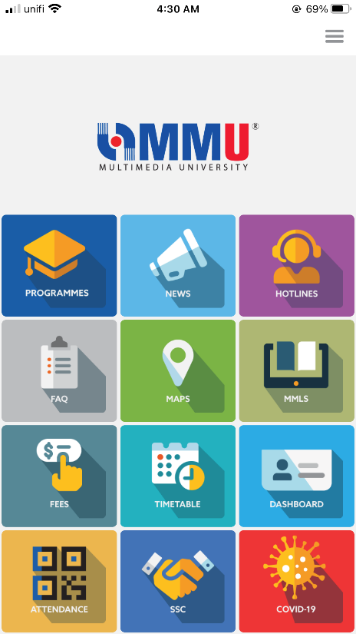

*Figure 2.4 MMU Mobile*

MMU Mobile are an application that are created to ease the students and staff to check campus related information. The features include dashboard, class schedule, campus info, scan attendance and health pass. The green health pass can be obtained when students fill in the daily health declaration form for 10 days consecutively with good health condition.

Advantages

* User friendly UI

The application interface is not messy as it shows the features at the dashboard neatly. The design are also user friendly since it use font and icon that can be seen and understandable.

* Scan features

MMU Mobile application provide features where students can scan the QR code provided by the lecturer for class attendance. After the covid 19 cases rise, they update the application by adding the features to scan the venue in MMU.

* Receive notifications

Whenever there are news, announcement or documents uploaded, everyone with the application will get a notification. This can help user to keep track of what’s happening in MMU.

Disadvantages

* No update or upload features

Since this application is more to information guide, it didn’t allow the user to upload or update anything not even their profile details.

* No QR code features

The QR code features is not available for user so it waste a lot of time when the guard have to see the green health pass, approval letter and check temperature.

### 2.1.2 Gerak Malaysia

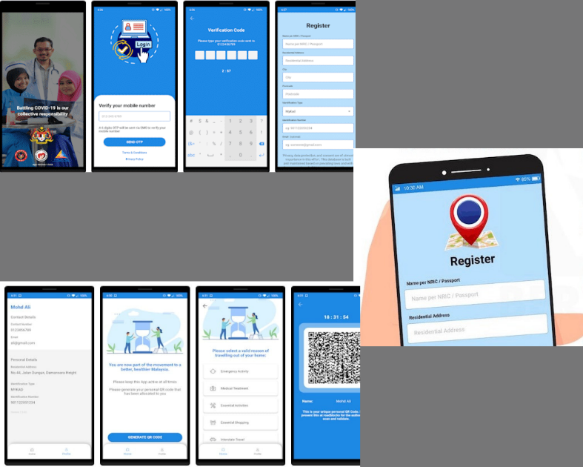

*Figure 2.5 Gerak Malaysia*

Gerak Malaysia is an application that is develop by MCMC and PDRM to track, manage, trace close case of covid 19 as well as managing the interstate travel permit. The application are mainly for the people who need to return home. This travel permit only allow one way travel and the journey on the highway are divided by states.

Advantages

* High security

The application ask for the user TAC number that are sent to their phone number to secure their account.

* Tracking features

It can trace the user location by using GPS location and the user need to allow it to cooperate with the police.

* Good UI

The interface design are really simple and easy to understand.

* QR code available

The availability of the QR code is very good to speed up the process at the roadblock location.

Disadvantages

* Incompetence

The disadvantages of this application is that the user need to update the application a lot of time just for them to request the permit and fill in the form. The application also always froze and lagging.

* Flow unclear

Even though the UI is very easy to understand, but the flow for this application to work is a bit messed up so it is not suitable for people who is not tech savvy.

* No notification

There are no notification for the user to know if they are approved or denied.

## 2.2 Comparison

Table 2.1 Comparison between existing applications

|  |  |  |  |  |  |  |
| --- | --- | --- | --- | --- | --- | --- |
| Features | Existing Systems | | | | | ITPS |
| Manual | BPR | MySejahtera | MMU Mobile | Gerak Malaysia |
| Pre-request using online form | 🗶 | ✔ | 🗶 | 🗶 | ✔ | ✔ |
| Upload supporting documents | 🗶 | ✔ | 🗶 | 🗶 | ✔ | ✔ |
| View real time logs at dashboard | 🗶 | 🗶 | ✔ | 🗶 | ✔ | ✔ |
| Good User interface | 🗶 | ✔ | 🗶 | ✔ | 🗶 | ✔ |
| Generate statistics report | 🗶 | ✔ | ✔ | 🗶 | ✔ | ✔ |
| Edit profile details | 🗶 | ✔ | ✔ | 🗶 | ✔ | ✔ |
| View status | 🗶 |  | ✔ | 🗶 | ✔ | ✔ |
| Generate QR code | 🗶 | 🗶 | ✔ | 🗶 | ✔ | ✔ |
| Scan QR code | 🗶 | 🗶 | ✔ | ✔ | 🗶 | ✔ |
| Able to connect to ANPR camera | 🗶 | 🗶 | 🗶 | 🗶 | 🗶 | ✔ |

# Chapter 3 : REQUIREMENTS

## 3.1 System Overview

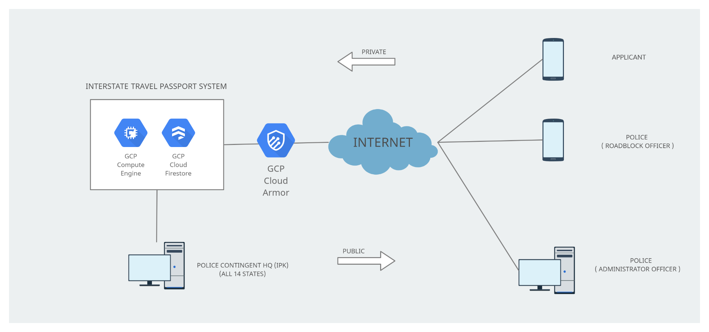

*Figure 3.1 System Overview*

Figure above display how the Interstate Travel Passport System workflow process. This system use Google Cloud Platform (GCP) for the server side and all of the users will access through Internet. The flow will start with the 14 States Police HQ (IPK) that report to Bukit Aman, RMP HQ where they will manage at the server side. Google Cloud Platform (GCP) provide a lot of services that can be use to develop an application. To secure the infrastructure, GCP Cloud Armor is used as a WAF where it can protect from attacks.

Next, Google Compute Engine is used because of their capability to maintain the stable services for the VM. The system can run everyday without interruption. As for the database, Firestore are chosen because it has extra features and a fast NoSQL that can be stored at cloud.

This system are mainly for applicant, roadblock officer and administrator officer where they have to use a device that support Google Play for the mobile-based application and Windows for the web-based application.

## 3.2 System Requirements

### 3.2.1 Software

* Android OS

Version Android 8.0 to Android 11.0

* Android Studio

User Interface

* Google Cloud Platform (GCP)
* Compute Engine for the VM
* Cloud Armor for WAF
* Firebase

Cloud Firestore as the database

* Windows OS

Version 8.1 and 10.0

### 3.2.2 Hardware

* Android devices

Phone and Tablets that support AndroidOS

## 3.3 Functional Requirements

### 3.3.1 Use Case Diagram

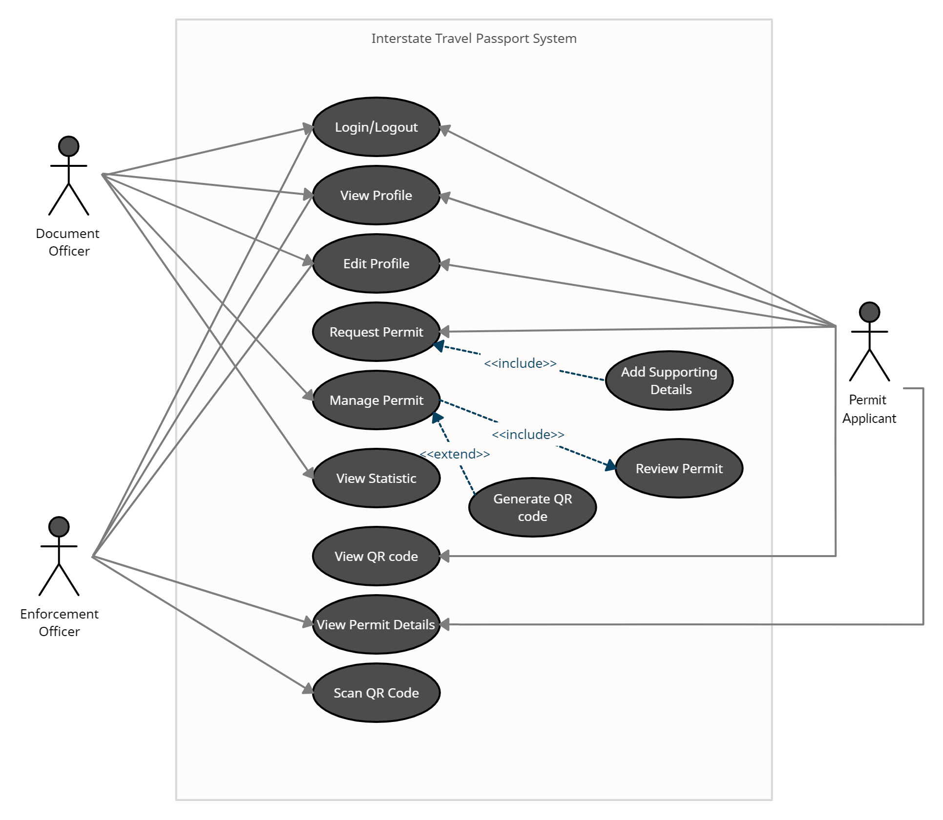

*Figure 3.2 Use Case Diagram*

### 3.3.2 Software Requirement Specifications (SRS)

Table 3.1 Use Case 1

|  |  |  |
| --- | --- | --- |
| UC 1 | Login/Logout | |
| Summary | User can sign in with username and password based on their roles. | |
| Success End Condition | User can access the application and directly to dashboard. | |
| Failed End Condition | User cannot access and error message will be shown. | |
| Primary,Secondary Actors | Permit Applicant, Enforcement Officer, Document Administrator (Primary) | |
| Description | Step | Action |
|  | 1 | User can open the ITPS application. |
|  | 2 | At the sign in screen, user have to fill in the username and password and click login. |
|  | 3 | The username and password are obtained when user create an account during sign up. |
|  | 4 | If the username and password is valid, the user will be taken to dashboard screen. |
| Extensions | Step | Branching Action |
|  | 1 | If the username and password is invalid, the user cannot access the application. |
|  | 2 | Error message will be shown : Wrong username/password |

Table 3.2 Use Case 2

|  |  |  |
| --- | --- | --- |
| UC 2 | View Profile | |
| Summary | User can view their profile based on the information during sign up. | |
| Success End Condition | User can check their profile details. | |
| Failed End Condition | No profile details is shown. | |
| Primary,Secondary Actors | Permit Applicant, Enforcement Officer, Document Administrator (Primary) | |
| Description | Step | Action |
|  | 1 | User can click at the Profile button. |
|  | 2 | At the Profile page, user can view their details. |
|  | 3 | The details include Name, IC number, Address, Phone number, Email and profile picture.  For the police side, their Police ID will be included. |
| Extensions | Step | Branching Action |
|  | 1 | If the user did not provide any information during sign up, user cannot proceed to next step. |

Table 3.3 Use Case 3

|  |  |  |
| --- | --- | --- |
| UC 3 | Edit Profile | |
| Summary | User can edit their profile if there are any changes. | |
| Success End Condition | Updated details is recorded. | |
| Failed End Condition | User cannot update. | |
| Primary,Secondary Actors | Permit Applicant, Enforcement Officer, Document Administrator (Primary) | |
| Description | Step | Action |
|  | 1 | User can click at the Profile button and at the Profile page, a smaill icon button to edit the profile is available. |
|  | 2 | The details that can be edited are only Address, Phone number, Email and profile picture. |
|  | 3 | After editing the information, user can click confirm and view the updated details. |
| Extensions | Step | Branching Action |
|  | 1 | If the user did not click Confirm, the details will remain unchanged. |

Table 3.4 Use Case 4

|  |  |  |
| --- | --- | --- |
| UC 4 | Request Permit | |
| Summary | User can apply for a permit via mobile application. | |
| Success End Condition | User’s permit details is recorded. | |
| Failed End Condition | No data is shown. | |
| Primary,Secondary Actors | Permit Applicant (Primary) | |
| Description | Step | Action |
|  | 1 | User can choose the Request button at dashboard. |
|  | 2 | User will be taken to screen where they have to fill in the form. |
|  | 3 | User need to select a police station and insert details such as Name, IC Number, Citizenship, Address, Type of Car, Number plate, Total dependent, Departure and Return date, Destination address and travel reasons. The user also need to include supporting documents such as IC copy, supporting letter and roadtax. |
|  | 4 | If all details and documents are complete, the user status will appear PENDING. |
| Extensions | Step | Branching Action |
|  | 1 | If the user did not include supporting documents, they cannot proceed to click submit and they will not get a status. |
|  | 2 | Error message will be shown : Please attach documents |

Table 3.5 Use Case 5

|  |  |  |
| --- | --- | --- |
| UC 5 | Manage Permit | |
| Summary | User can manage the permit via web application. | |
| Success End Condition | The status for applicant will be changed. | |
| Failed End Condition | No data is shown. | |
| Primary,Secondary Actors | Document Administrator (Primary) | |
| Description | Step | Action |
|  | 1 | User have to click at the List Of Applicants and choose permit applicants with PENDING status. |
|  | 2 | User will view the permit applicant’s details. |
|  | 3 | If the details are complete and the reasons to travel are reasonable, the user will click Approve. |
|  | 4 | The user will be brought to a screen where they will generate a QR code based on the duration stated. After the user click Generate, the status for applicant will change to APPROVED and the permit applicants will receive the QR code. |
| Extensions | Step | Branching Action |
|  | 1 | If the details are incomplete and not acceptable, the user will click Reject and will be brought to a screen where a reasons of rejection should be included. |

Table 3.6 Use Case 6

|  |  |  |
| --- | --- | --- |
| UC 6 | View Statistics | |
| Summary | User can view the total of permit applicants. | |
| Success End Condition | Graph and report will be generated. | |
| Failed End Condition | Error message will be shown. | |
| Primary,Secondary Actors | Document Administrator (Primary) | |
| Description | Step | Action |
|  | 1 | User can click the Statistics button. |
|  | 2 | The statistics can be seen by daily,monthly and yearly. |
|  | 3 | User can click generate report. |
| Extensions | Step | Branching Action |
|  | 1 | Error message or no data will be shown. |

Table 3.7 Use Case 7

|  |  |  |
| --- | --- | --- |
| UC 7 | View QR Code | |
| Summary | User will view the QR code at their mobile phone. | |
| Success End Condition | QR code available at Status. | |
| Failed End Condition | No QR code shown. | |
| Primary,Secondary Actors | Permit Applicant (Primary) | |
| Description | Step | Action |
|  | 1 | User can click at Status button. |
|  | 2 | The QR code will be shown along with the APPROVED status so user can show to the enforcement officer at roadblock. |
| Extensions | Step | Branching Action |
|  | 1 | If the user did not go to the police station after requesting, the document administrator cannot proceed with it therefore no QR code will be given. |
|  | 2 | Status will remain PENDING. |

Table 3.8 Use Case 8

|  |  |  |
| --- | --- | --- |
| UC 8 | View Permit Details | |
| Summary | User can view the applicants permit details. | |
| Success End Condition | The permit details of the applicant will be shown. | |
| Failed End Condition | No data is shown. | |
| Primary,Secondary Actors | Enforcement Officer (Primary) | |
| Description | Step | Action |
|  | 1 | After the user scan the QR code from the applicants phone, the permit details will be shown. |
|  | 2 | The permit details include the applicant’s status including the information that filled by them when requesting the permit. |
| Extensions | Step | Branching Action |
|  | 1 | If the applicant’s status is rejected, the user can click the reasons of rejection. |

Table 3.9 Use Case 9

|  |  |  |
| --- | --- | --- |
| UC 9 | Scan QR Code | |
| Summary | User can scan the QR code. | |
| Success End Condition | The applicant’s permit details will appear. | |
| Failed End Condition | Error message will be shown. | |
| Primary,Secondary Actors | Enforcement Officer (Primary) | |
| Description | Step | Action |
|  | 1 | User can click the Scan button. |
|  | 2 | User have to scan the QR code from the applicant’s device. |
|  | 3 | If the QR code is valid, all information will be shown. |
| Extensions | Step | Branching Action |
|  | 1 | If the QR code is invalid, error message will be shown. |

### 3.3.3 Context Diagram

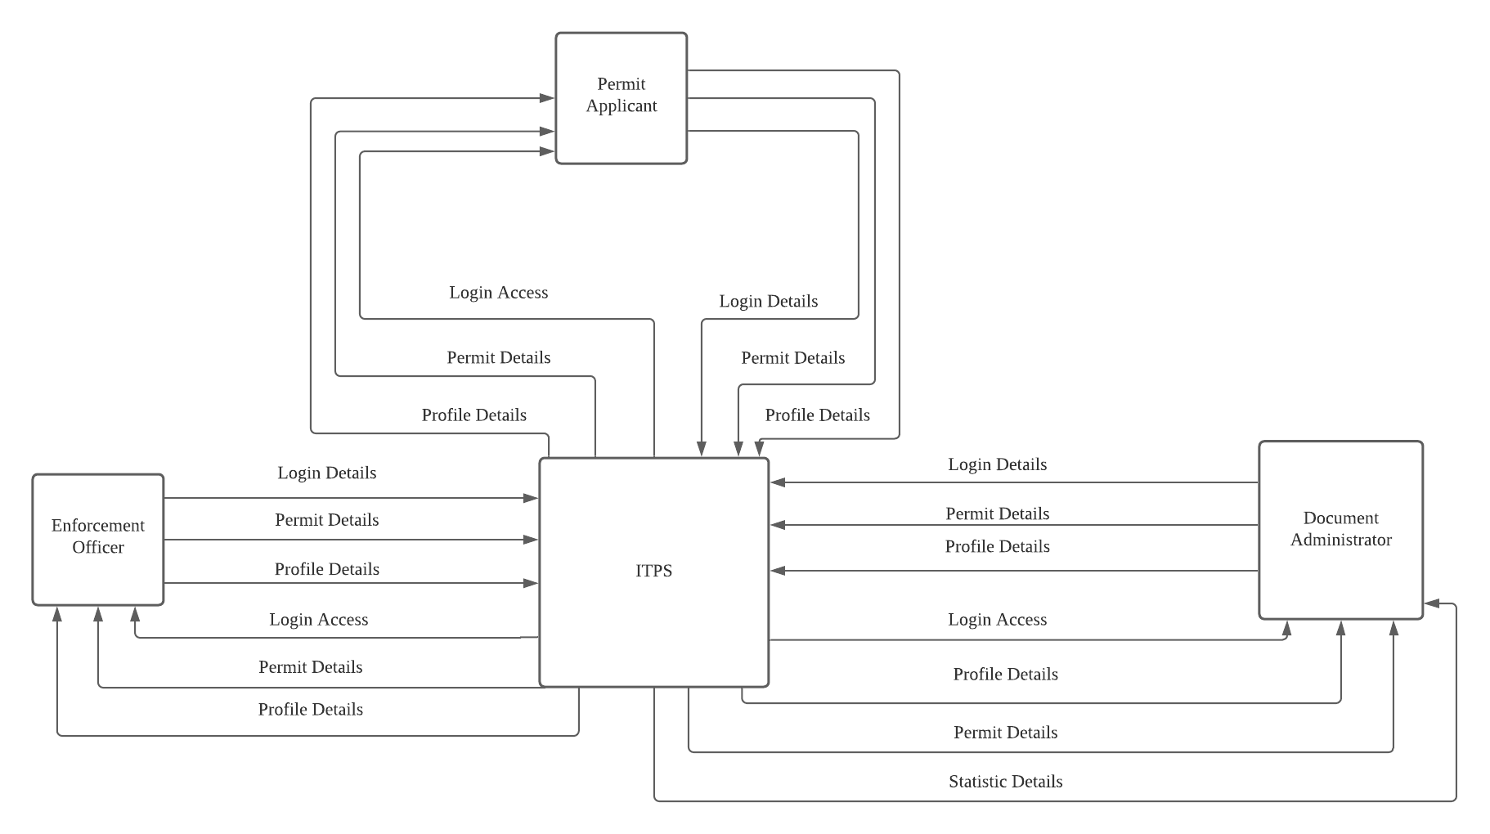

*Figure 3.3 Context Diagram*

### 3.3.4 Data Flow Diagram

*Figure 3.4 DFD Permit Applicants*

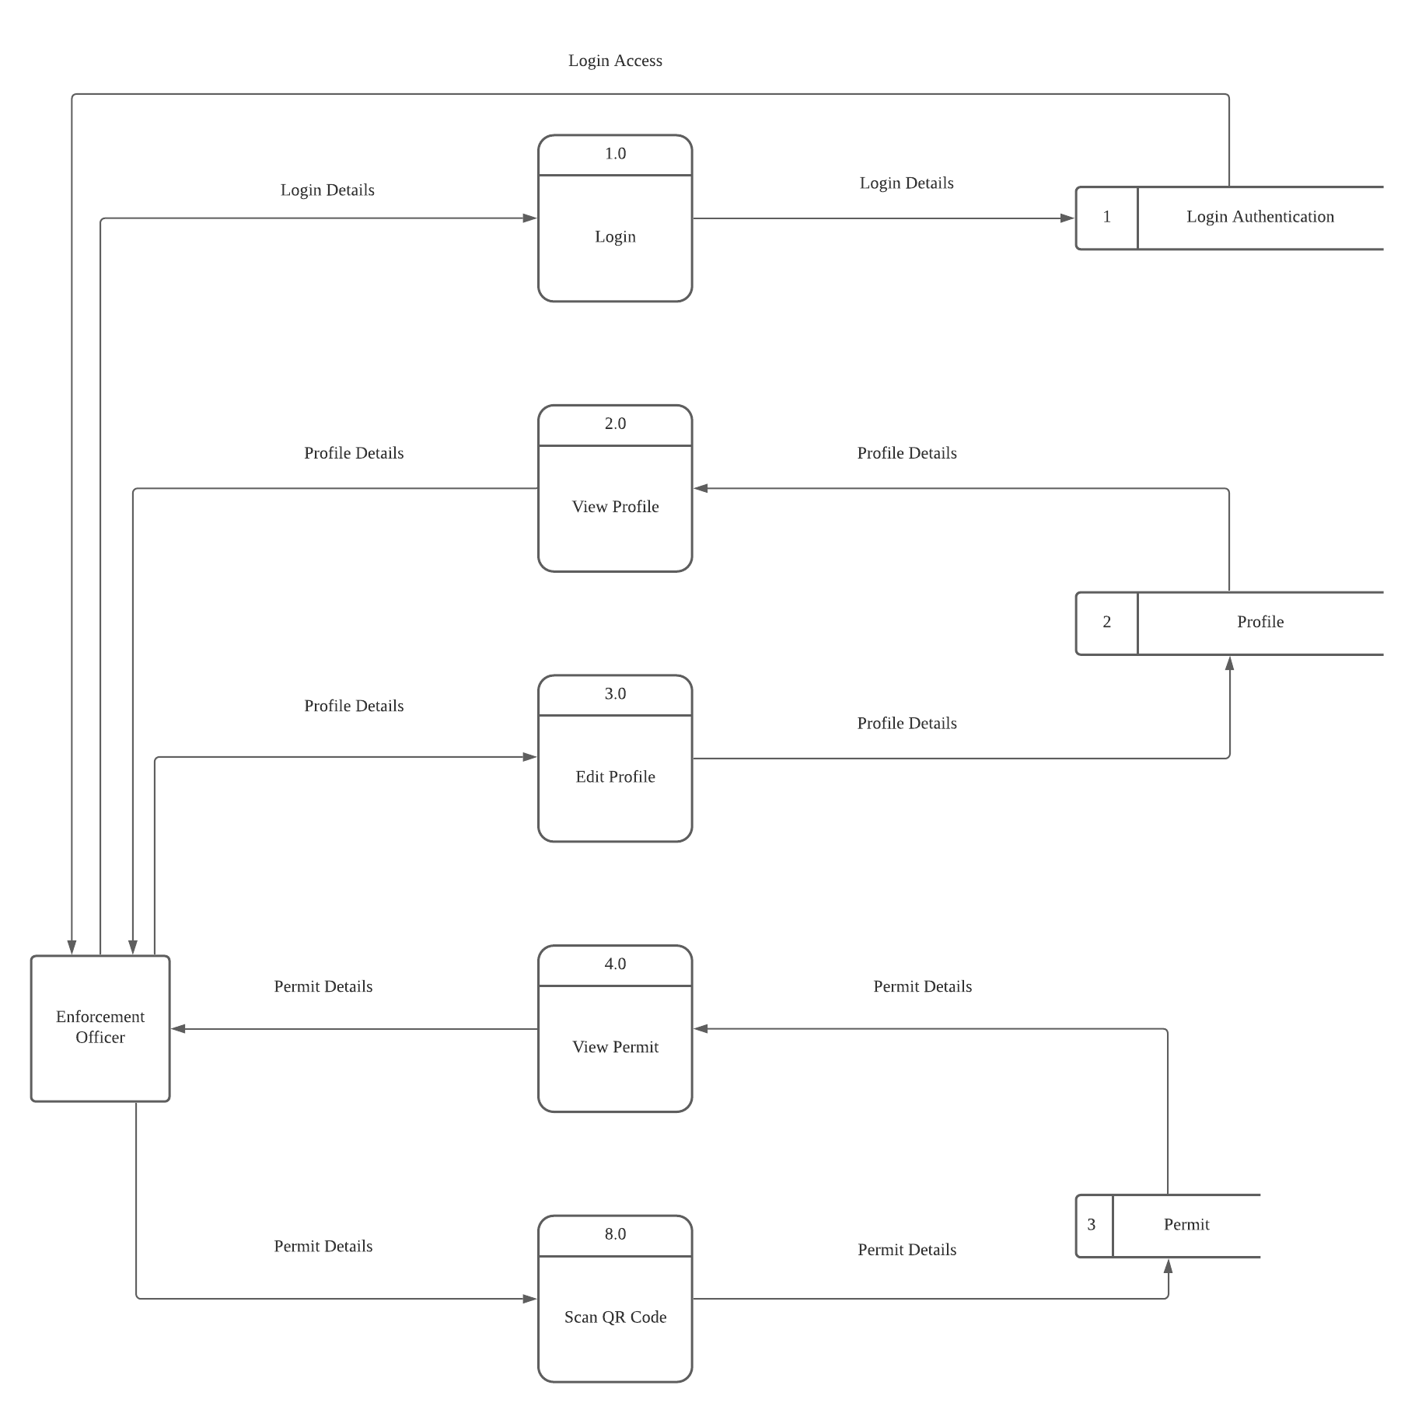

*Figure 3.5 DFD Enforcement Officer*

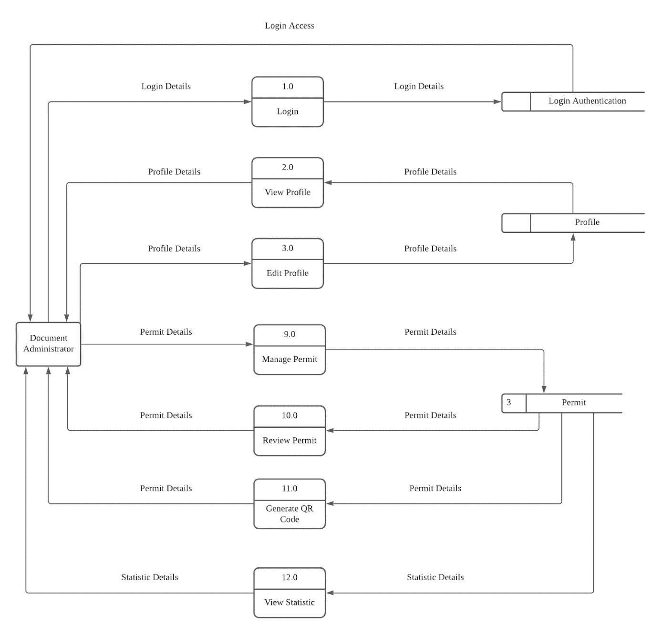

*Figure 3.6 DFD Document Administrator*

## 3.4 Non Functional Requirements

**Availability**

The system should function 24 hours so the applicant can request the permit anytime before going to the police station.

**Usability**

The system interface should use medium or large fonts for user to easily read and understand the words.

**Perfomance**

Each submission should process within 3 seconds.

**Security**

Do a penetration test or source code audit monthly to avoid backdoor attack.

# Chapter 4 : DESIGN

## 4.1 Sequence Diagrams

### 4.1.1 Permit Applicants

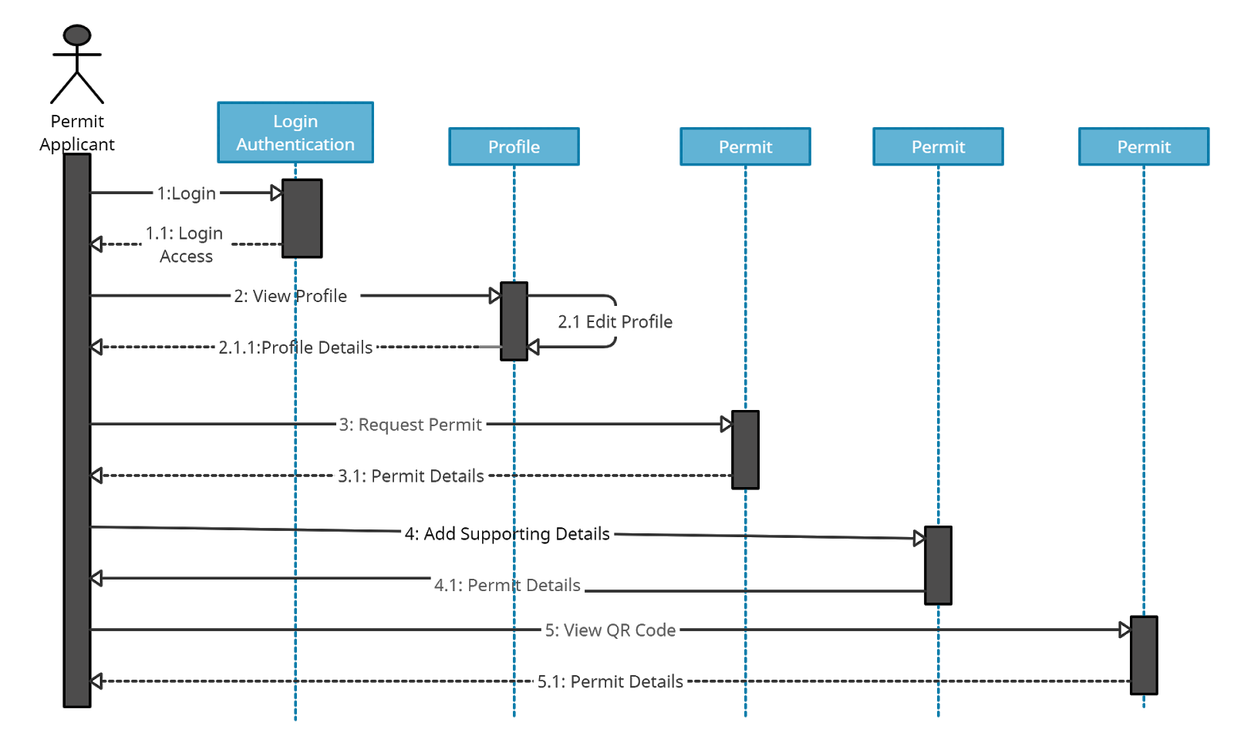

*Figure 4.1 Sequence Diagram Permit Applicant*

### 4.1.2 Enforcement Officer

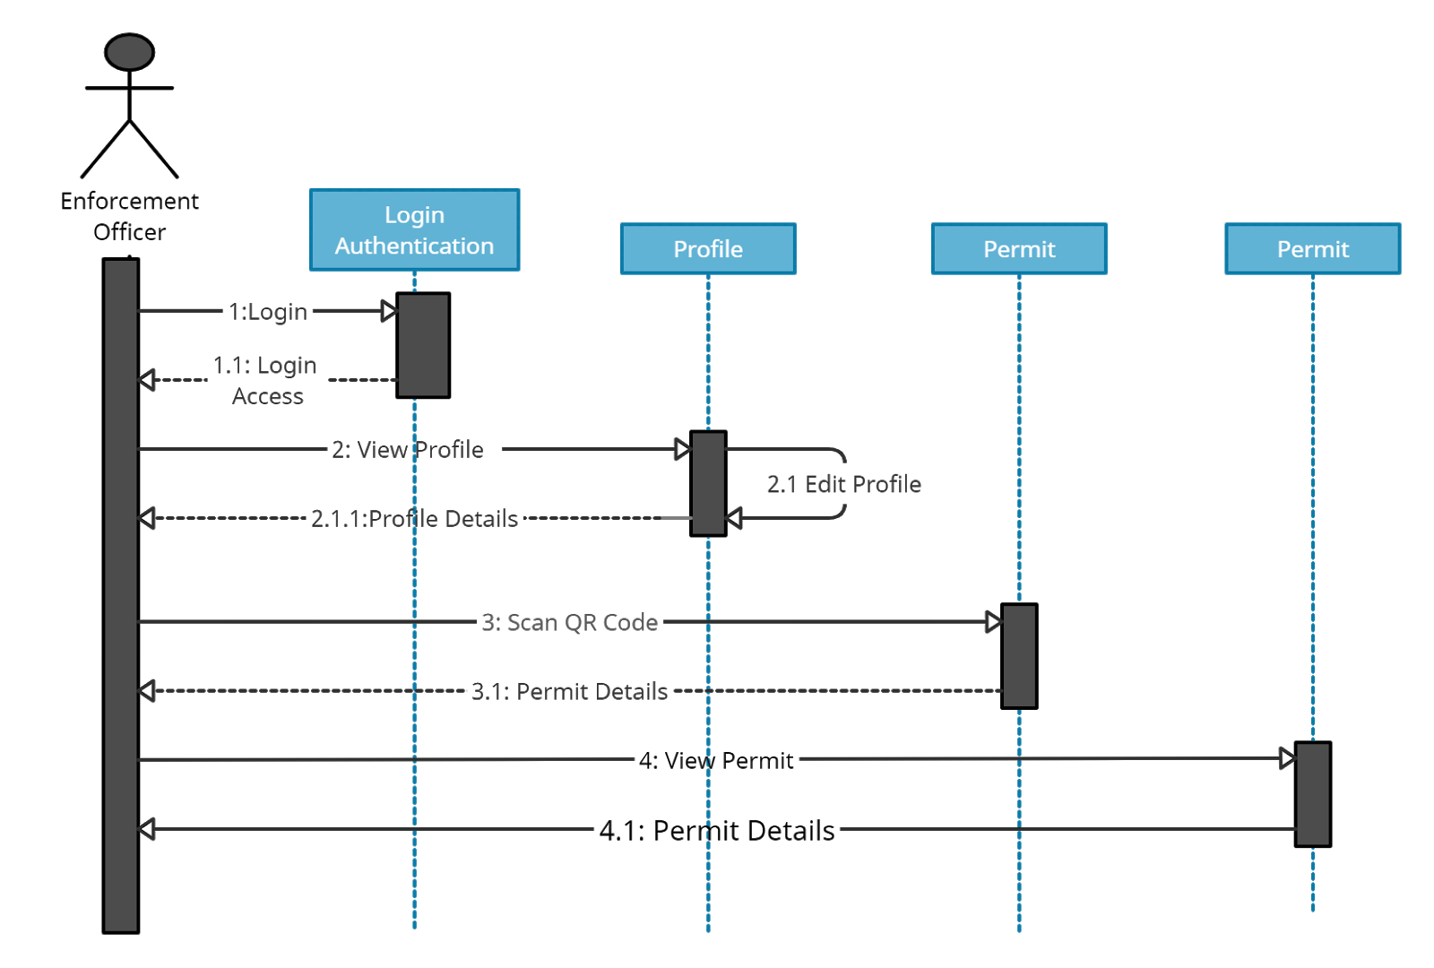

*Figure 4.2 Sequence Diagram Enforcement Officer*

### 4.1.3 Document Administrator

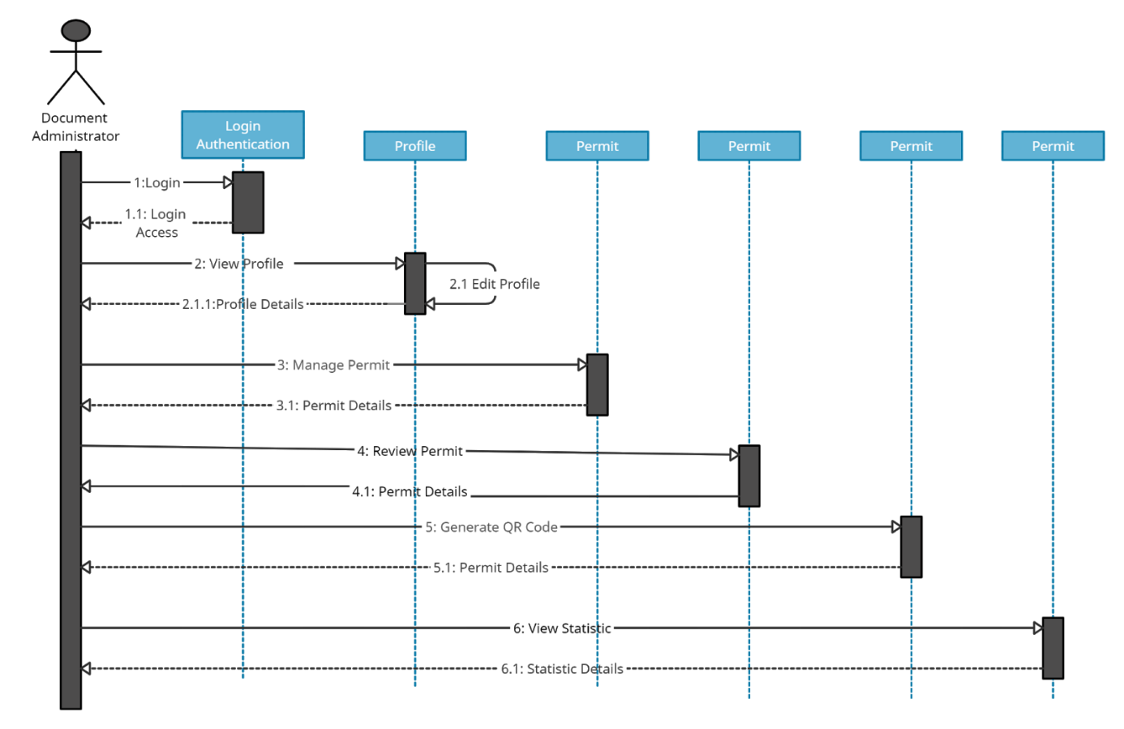

*Figure 4.3 Sequence Diagram Document Administrator*

## 4.2 Prototype

### 4.2.1 Mobile-based Application for Permit Applicants

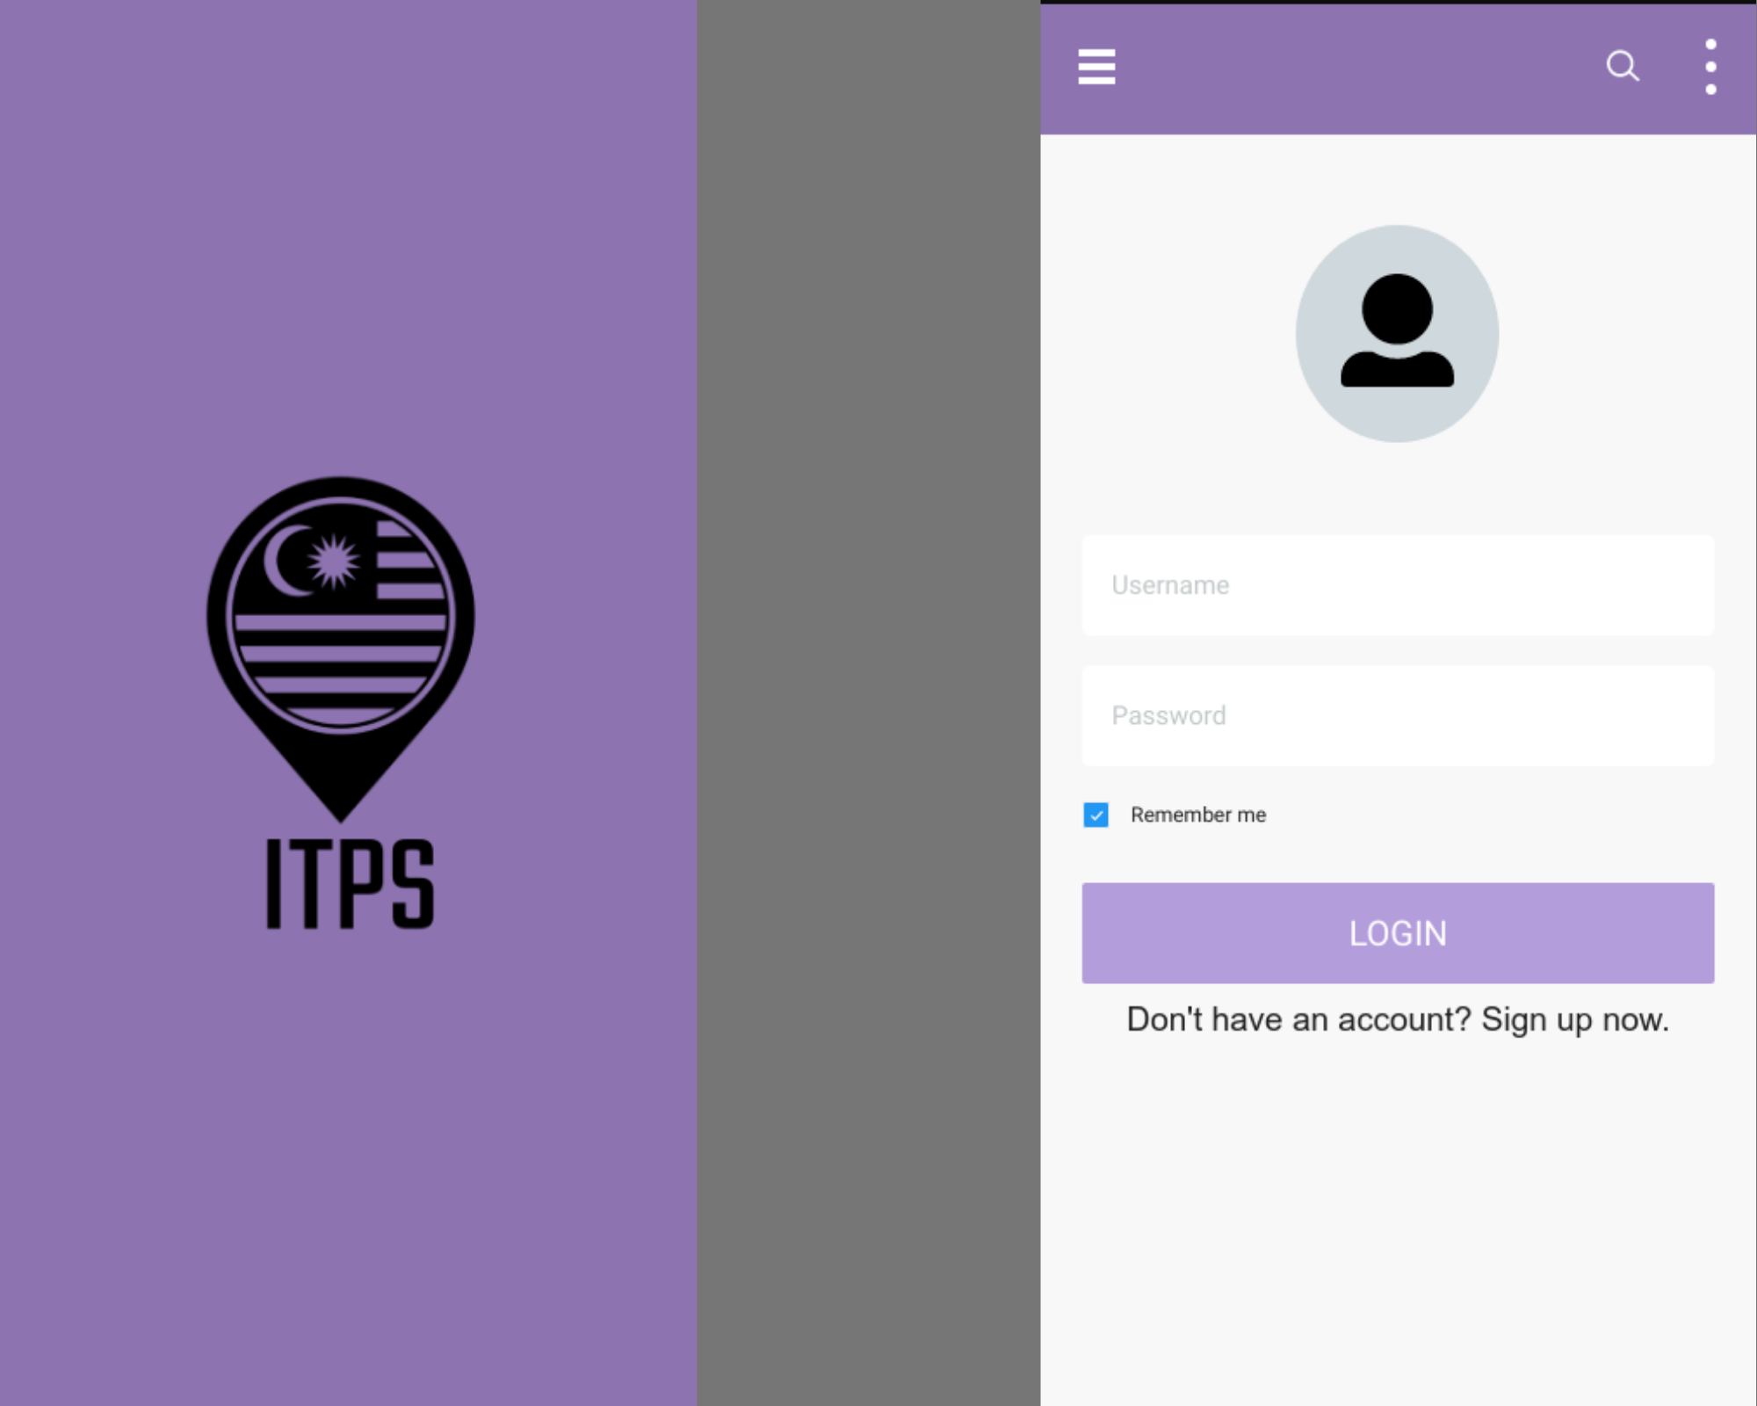

*Figure 4.4 Splash Screen and Login*

Figure 4.4 shows the splash screen that the user will see upon opening the applications and they can sign in using username and password.

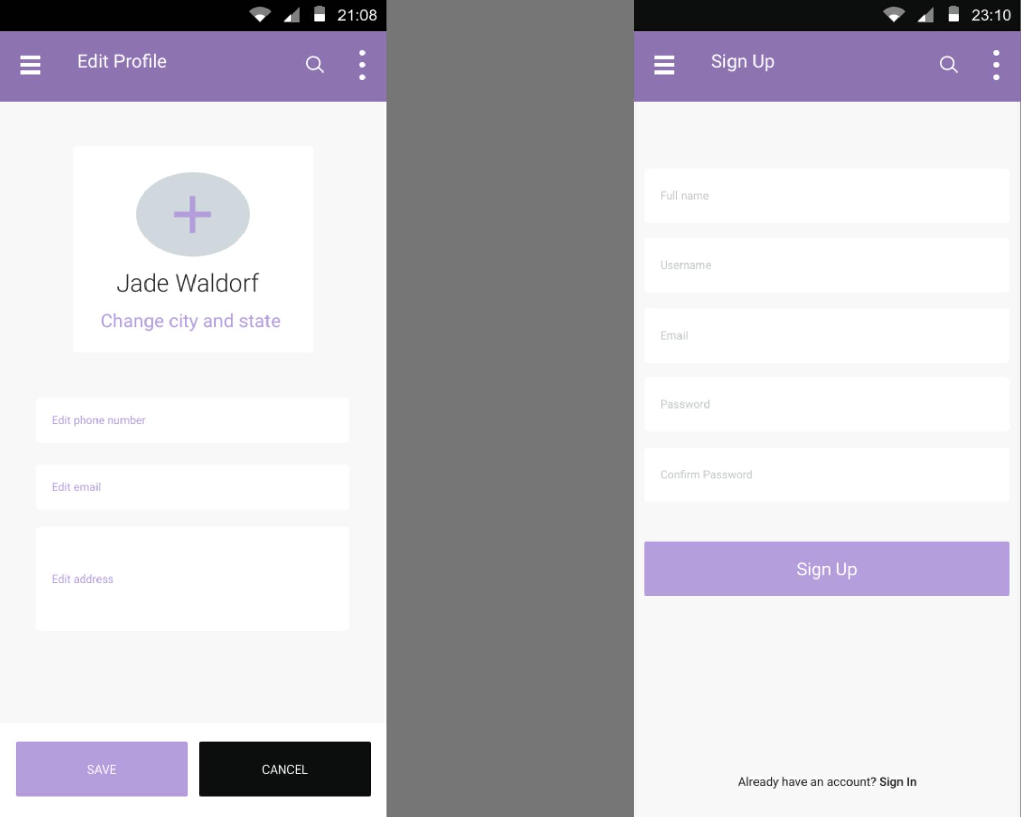

*Figure 4.5 Edit Profile and Sign Up*

Figure 4.5 shows the Edit profile and Sign up screen. User can change only their profile picture, Address, phone number and email. At the sign up page, user have to fill in the details such as Full name, username, email and password to create an account.

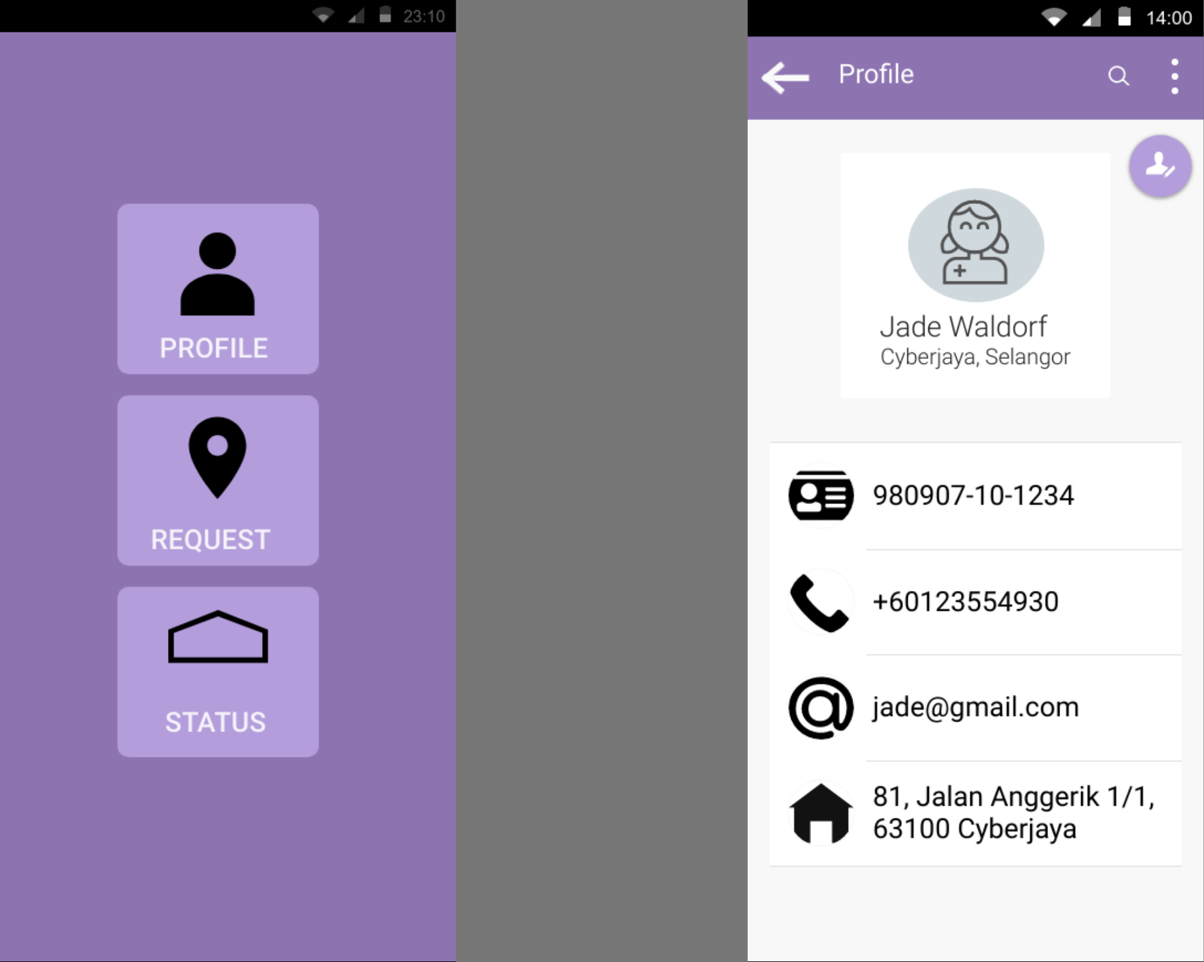

*Figure 4.6 Dashboard and Profile*

Figure 4.6 shows the dashboard where 3 choices are available for user to choose. The profile button is where user can view their profile and edit it. The request button is for the user to apply for a Interstate Travel permit. Lastly, the status button is where user can check their status such as APPROVED or PENDING. This is also where user can show the enforcement officer their QR code. The profile page include details that is keyed in by user during sign up.

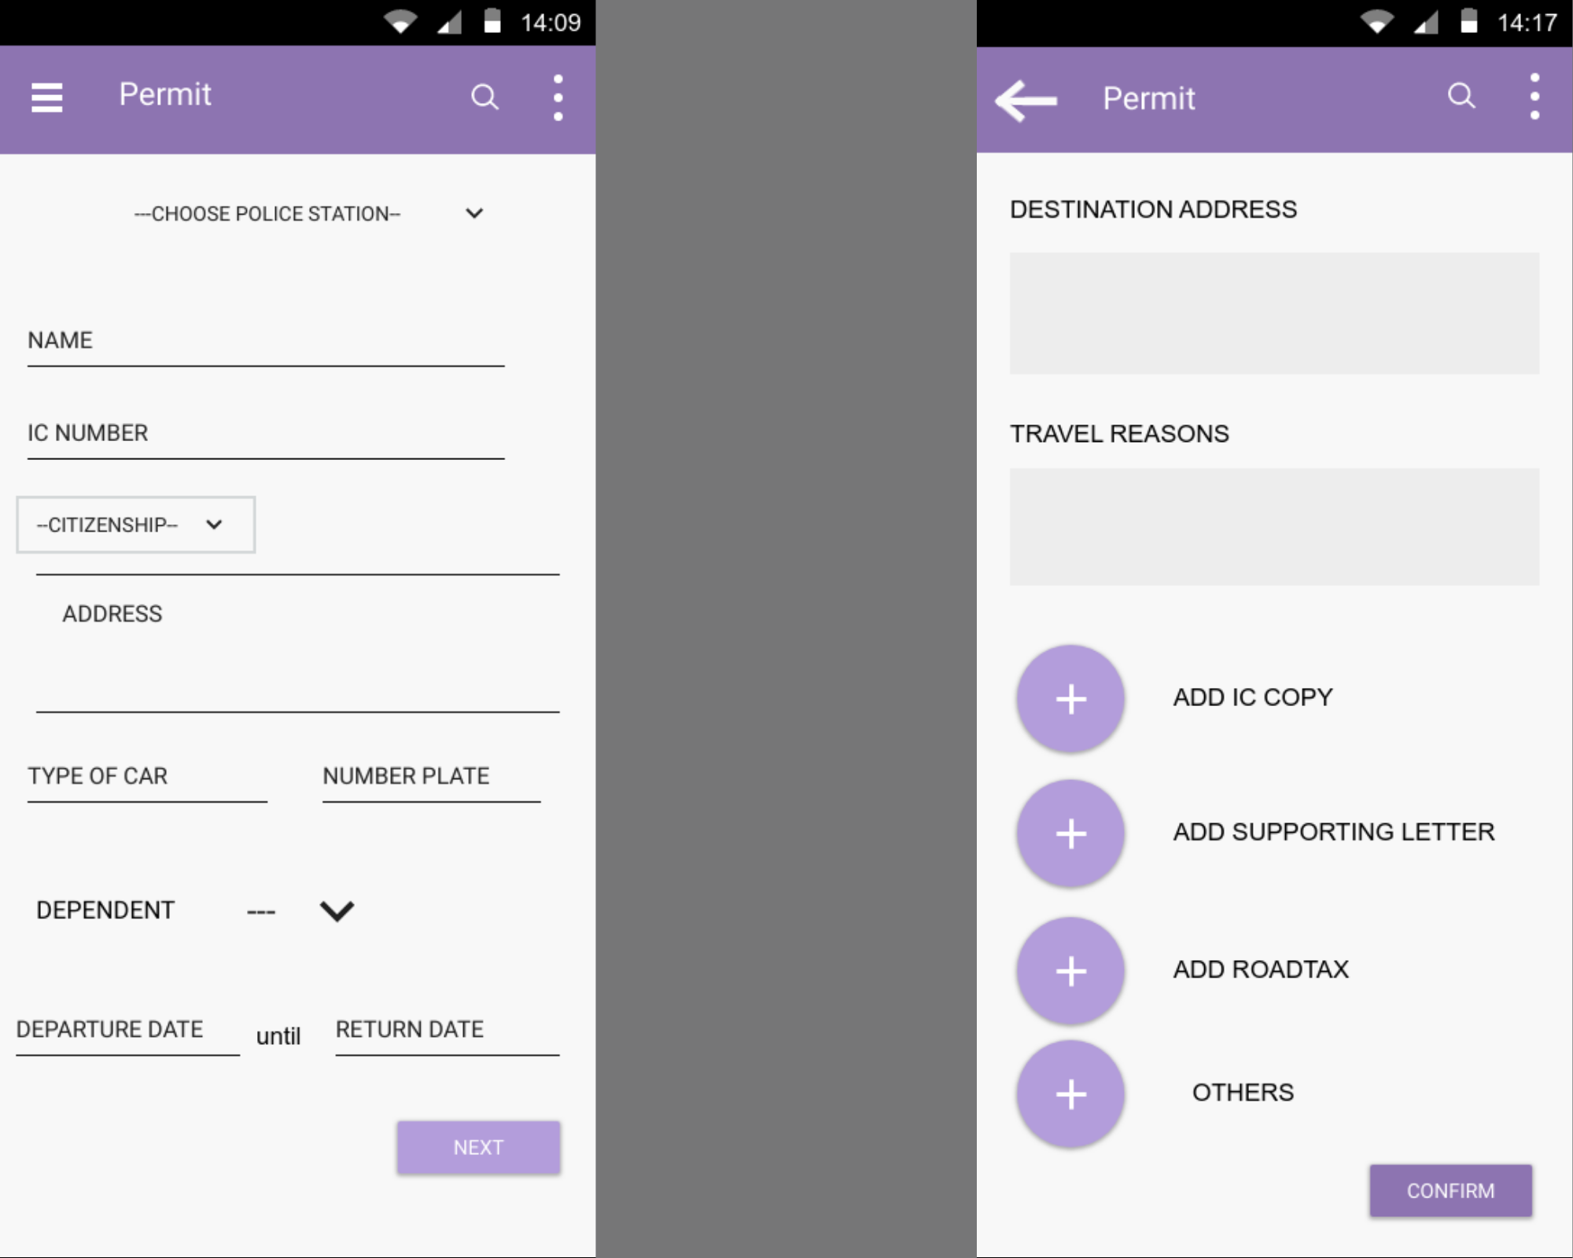

*Figure 4.7 Permit*

Figure 4.7 is the request permit screen and user also need to add supporting documents before clicking Confirm.

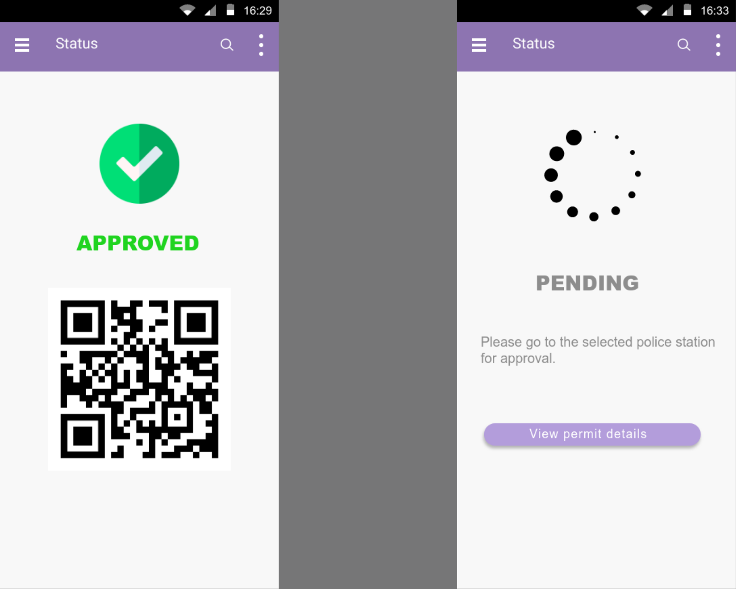

*Figure 4.8 Status for APPROVED and PENDING*

Figure 4.8 shows the screen after the user go to the police station for the document administrator to review their permit while the PENDING page is after the user submit their permit details.

### 4.2.2 Mobile-based Application for Enforcement Officer

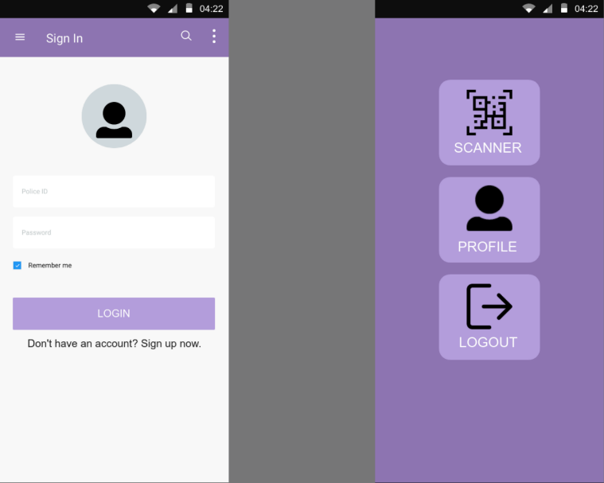

*Figure 4.9 Sign In and Dashboard*

Figure 4.9 display the Sign In and dashboard screen for the enforcement officer. The officer can sign in through the applications using their Police ID. They can click at the scanner button to scan the applicant’s QR code at the roadblock.

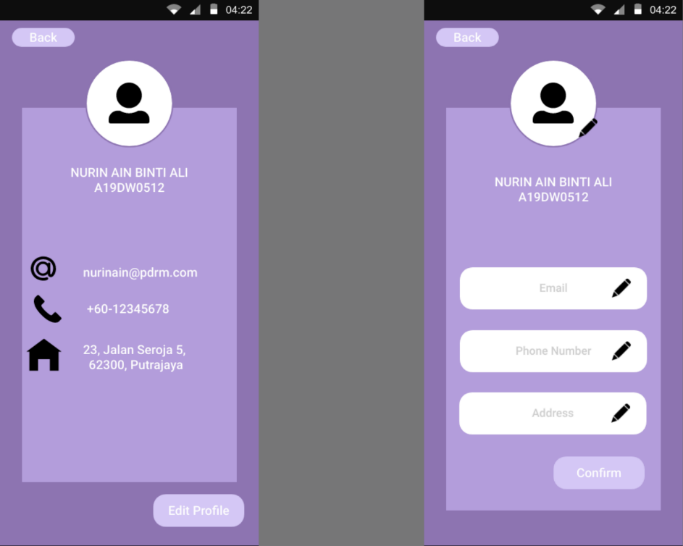

*Figure 4.10 Profile and Edit Profile*

Figure 4.10 display the profile and edit profile.

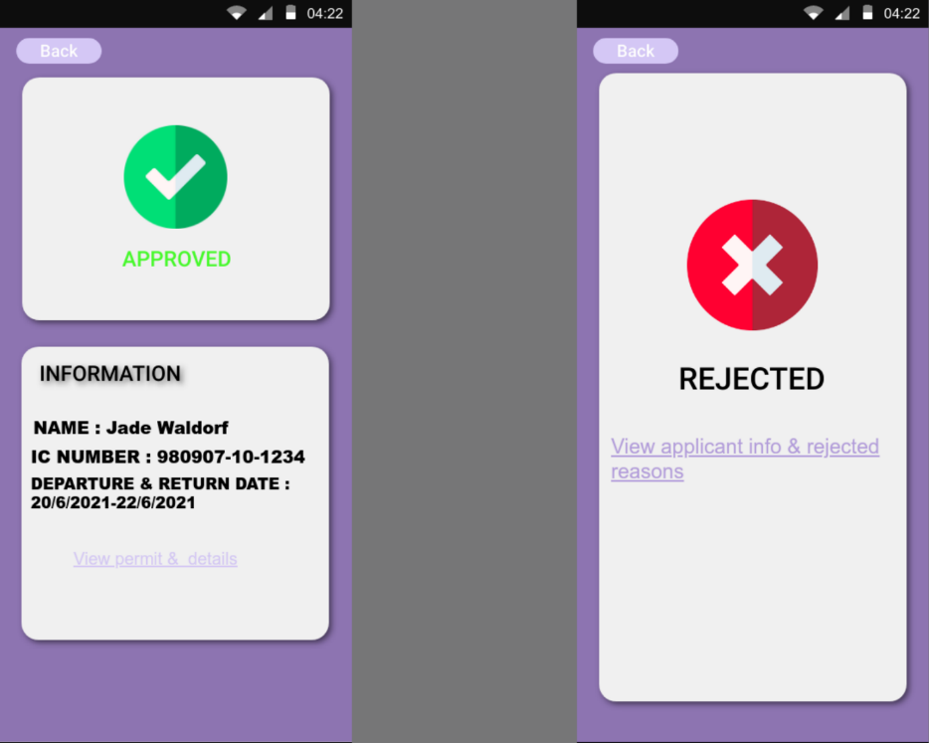

*Figure 4.11 Approved and Rejected Screen*

Figure 4.11 display the view that the user will see after they scan the QR code.

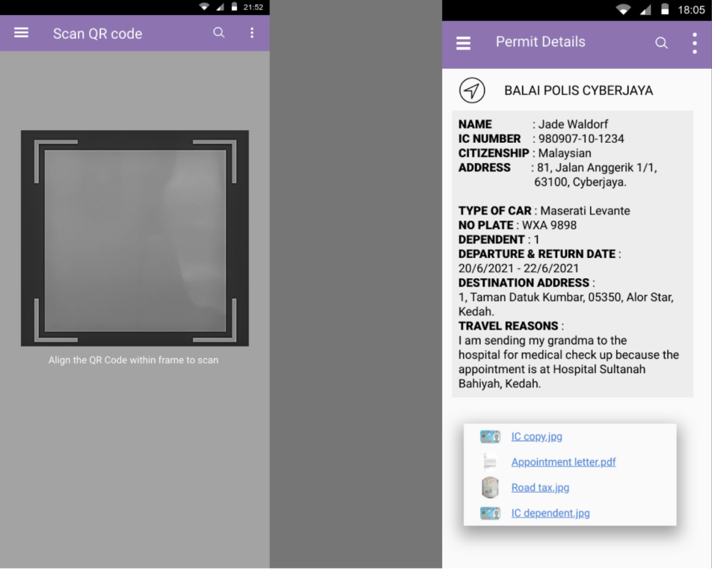

*Figure 4.12 Scan and Permit Details*

Figure 4.12 display the scan and permit details screen where the permit details is from the applicant’s permit.

### 4.2.3 Web-based Application for Document Administrator

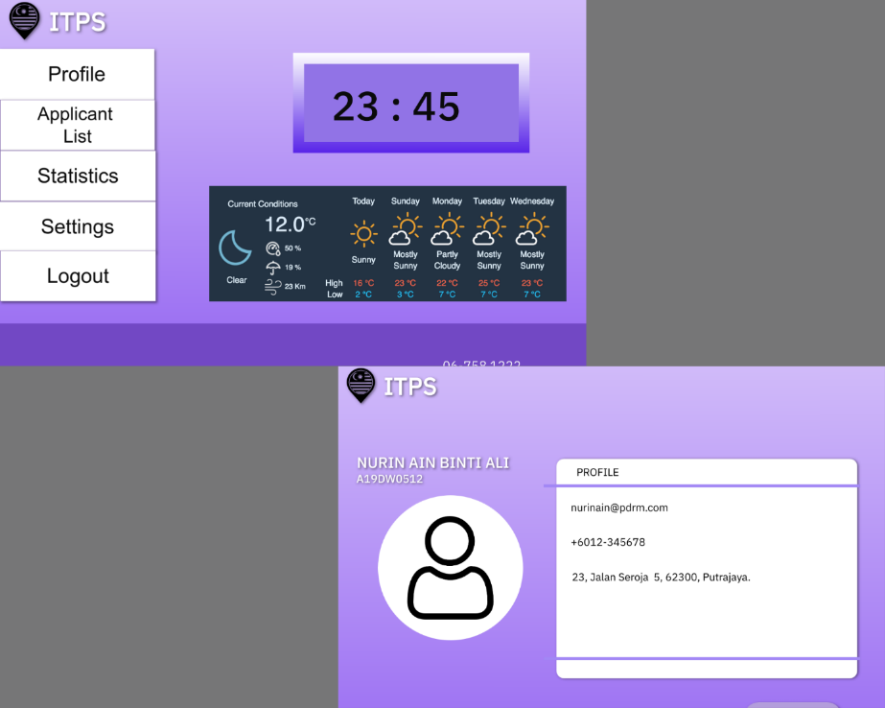

*Figure 4.13 Dashboard and Profile*

Figure 4.13 shows the dashboard and profile screen for the document administrator

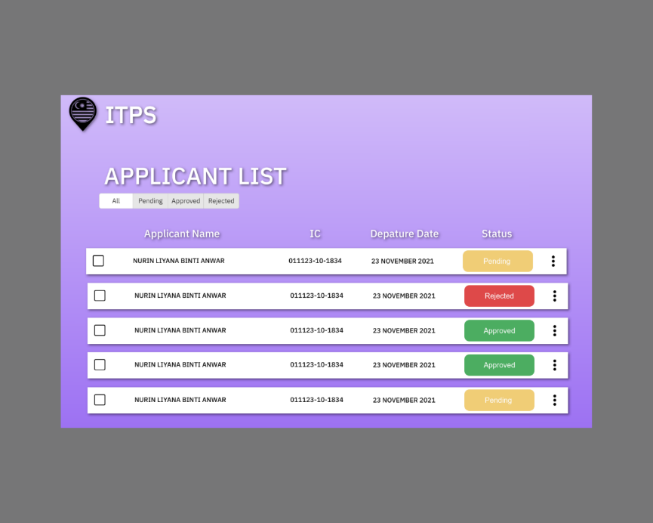

*Figure 4.14 Applicant list*

Figure 4.14 shows the list of applicants. The user can sort the list by status. This can ease them to find the permit that is need to be review.

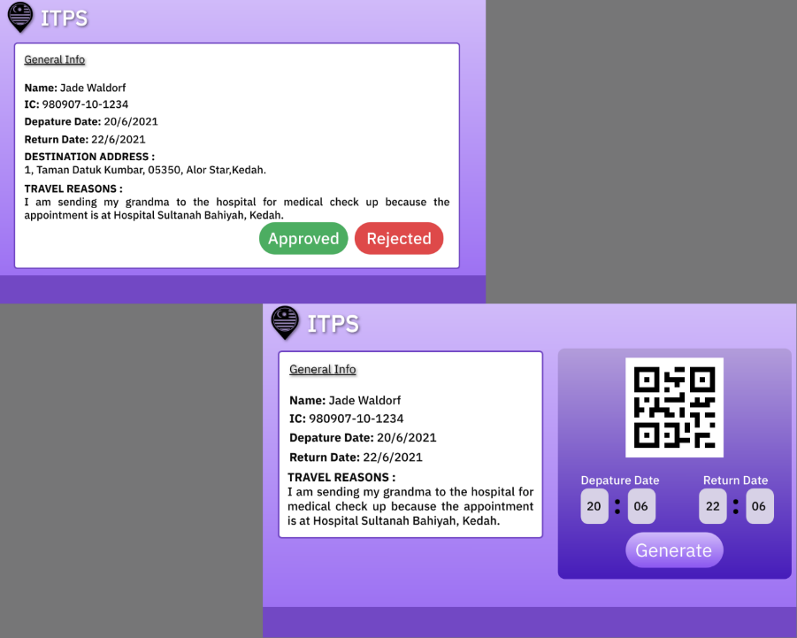

*Figure 4.15 Review and Generate QR code*

Figure 4.15 shows the review and generate QR code page. After the user check the details. They will review it by approving or rejecting the permit and if they approved, they will go to the generate QR code page where user can generate the QR code based on the travel date from their permit application.

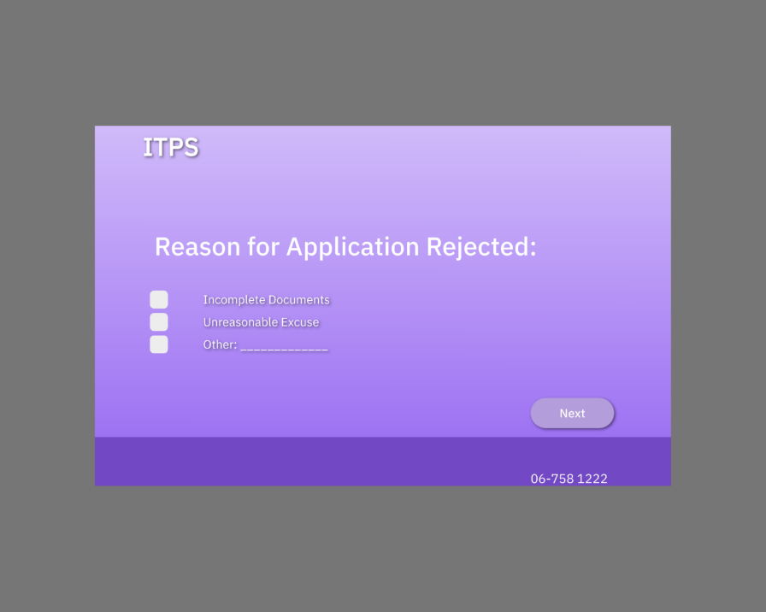

*Figure 4.16 Rejected reasons*

Figure 4.16 shows the screen if the user reject the applicant’s permit. They have to state the reasons and this will appear when the enforcement officer scan the rejected applicants, they can view the reasons.

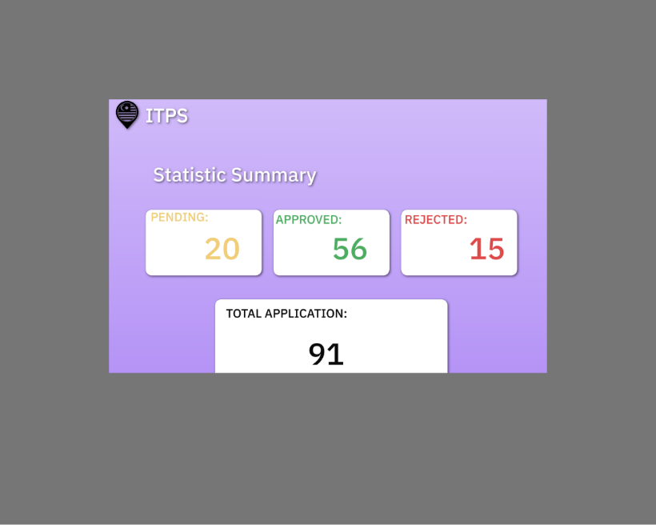

*Figure 4.17 Statistics*

Figure 4.17 shows the statistics page of the applicants that requested for an Interstate Travel permit.

# Chapter 5 : Implementation Plan

## 5.1 Part 1

*Table 5.1 Gantt Chart FYP 1*

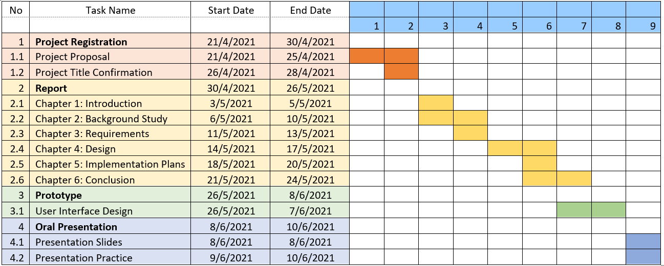

## 5.2 Part 2

*Table 5.2 Gantt Chart FYP 2*

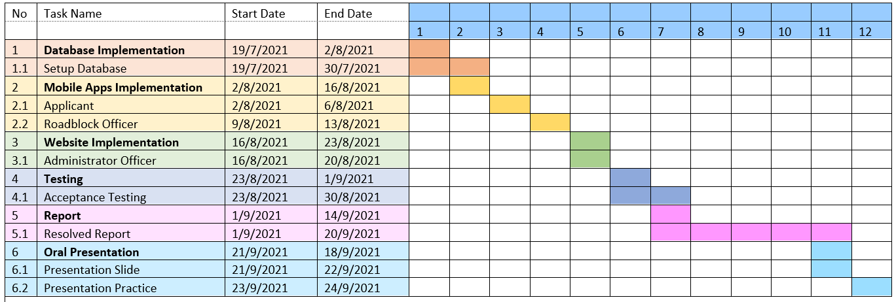

# Chapter 6 : Conclusion

## 6.1 Conclusion

The normal process of getting approval to cross the state that is currently using manual way is quite inconvenience to most of people especially the applicant and police officers. By developing this application, it helps to smoothen the process when they can save time and reduce paperwork.

The complete project include studying the system that is used which is Workflow Management System. All the requirements and type of workflow management is considered. Information such as what the current technology is needed to develop a system that can be use nowadays.

Next, for a project to be successful, it is necessary to conduct research on existing applications that use a similar system in order to compare and contrast the benefits and drawbacks of using it.

Aside from that, after listing the functional requirements and making a preparation to describe how the system will work for the client side, I develop an application for applicant to request the permit, roadblock officer to scan the QR code at the applicant’s device and administrator officer to manage the approval of the permit request using a system based on all problem and objectives that I require.

To conclude, the purpose of a system is usually to make the user's life easier. The next step in ensuring the success of this project is to implement the database and perform user testing for their perspectives. The challenges I faced and the knowledge I gained were valuable learning experiences for me, and they will help me prepare for future opportunities.

## 6.2 Obstacles

The obstacles for me are when I am trying to find existing applications that is similar to my project as references, but there are very limited info. Since I am proposing to develop a new system to update the manual way of Interstate Travel, this is a challenge for me because I need to understand how the process works.

Next, I have problems when choosing on what to use to develop the applications because I am not familiar with the platform. But, after a thorough survey, I finally decide to use Android Studio for user interface and Google Cloud Platform for the server.

## 6.3 Future work

For future work, it would be better to add iOS so the usage of this application can be expanded to users that use smartphone that support iOS. Other than that, another initiative that can help the police force is by applying Automatic Number Plate Recognition (ANPR). We can create robot as another roles in the system and by connecting to ANPR camera, it will detect the plate number. The plate number that is registered during requesting permit will be recognised.

# 

# References

Mysumber. (2020, May 5). Permohonan Gerak Malaysia Online Pergerakan Rentas Negeri. Mysumber.

Farah Solhi.(2020, October 2020). NSC: Police permit required for inter-state travel in or out of CMCO areas. New Straits Times.

Guest Post. (2020, June 5). 10 Features Your Workflow Management System Needs. Retrieved May 2,2021 from https://www.processmaker.com/blog/workflow-management-system/

Nikita Kozin. Malaysia Icon. Retrieved June 5,2021 from <https://thenounproject.com/term/malaysian-flag/221327/>. The Noun Project.

# 

# APPENDIX A : FYP 1 Meeting Logs



# TPT3101/TPR3321 Final Year Project (FYP1) Meeting Log

**Trimester 3, 2020/21 (Trimester ID:2030)**

|  |  |
| --- | --- |
| **Meeting Date:**  **26th April 2021** | **Meeting No.:**  **1** |
| **Meeting Mode:**  **Email** | |
| **Project ID:**  **1784** | **Project Type:**  **Application-based** |
| **Project Title :**  **Interstate Travel Passport System** | |
| **Student ID :**  **1161200418** | **Student Name:**  **Nurul Amira binti Anwar** |
| **Student Programme and Specialisation:**  **Bachelor in Information Technology ( Information Systems )** | |
| **Supervisor Name:**  **Dr. Wan Noorshahida binti Mohd Isa** | **Co-Supervisor Name:**  **(if applicable)** |
| **Collaborating Company:**  **(if applicable)** | **Company Supervisor Name:**  **(if applicable)** |

|  |
| --- |
| **1. WORK DONE**  *[Please write the details of the work done, after the last meeting]*  **Tasks:** **Problem Formulation and Project Planning** / ~~Background Study or Literature Review / Requirement Analysis or Theoretical Framework / Design or Research Methodology /~~  ~~Prototype Development or Proof of Concept / Draft Report Completion~~  *(Please strike out the tasks, which are not applicable for the work done, after the last meeting)*  **Details (in point form):**  - Discussion about the project details for the proposal submission  - Planning to add more features |
|  |
| **2. WORK TO BE DONE**  *[Please write the details of the work to be done, before the next meeting]*  **Tasks:** ~~Problem Formulation and Project Planning~~ / **Background Study or Literature Review** / ~~Requirement Analysis or Theoretical Framework / Design or Research Methodology /  Prototype Development or Proof of Concept/ Draft Report Completion~~  *(Please strike out the tasks, which are not applicable for the work to be done, before the next meeting)*  **Details (in point form):**     * Introduction * For the background study, find applications related to the system to study their features. * Find the problems or mistake from the user that will makes the system a good solution. |  |
| **3. PROBLEMS ENCOUNTERED AND SOLUTIONS**  *[Please write the details of the problems encountered, after the last meeting and provide the solutions / plan for the solutions]*     * The title is inconvenient   : Supervisor change the title to Interstate Travel Passport System |  |
| **4. COMMENTS (Supervisor / Co-Supervisor / Company Supervisor)**  Noted on progress. |  |

WanNShahida

……………………………                                                            …………………………...

Supervisor’s Signature                                                         Student’s Signature

……………………………..  ………………………………….

Co-Supervisor’s Signature         Company Supervisor’s Signature

**(if applicable)             (if applicable)**

**IMPORTANT NOTES TO STUDENTS:**

1. Items 1 – 3 are to be completed by the students prior to the meeting. Item 4 is to be completed by the supervisor / co-supervisor / company supervisor.
2. Student has to upload the soft copies of the meeting logs in Google Classroom and also attach them along with interim (FYP1) report.

Minimum requirement is FIVE Meeting Logs (Period: Week 3 to Week 7). Students can

have weekly meetings with the supervisor.

1. Log sheets provide the basis for evaluating the General Effort (Project Management, Attitude, and Technical Competency) of the student, by the supervisor and also for checking the attendance requirement of the student, by the FYP Committee.

This also provide the student with feedback from the supervisor / co-supervisor / company supervisor on the tasks done and provide the plan for the upcoming tasks. This can provide the motivation for the student to give consistent and efficient effort throughout the period of FYP.

1. Student who fails to meet the minimum requirement (five nos.) of log sheets will not be allowed to submit FYP report.



# TPT3101/TPR3321 Final Year Project (FYP1) Meeting Log

**Trimester 3, 2020/21 (Trimester ID:2030)**

|  |  |
| --- | --- |
| **Meeting Date:**  **3rd May 2021** | **Meeting No.:**  **2** |
| **Meeting Mode:**  **Online meeting ( Google Meet )** | |
| **Project ID:**  **1784** | **Project Type:**  **Application-based** |
| **Project Title :**  **Interstate Travel Passport System** | |
| **Student ID :**  **1161200418** | **Student Name:**  **Nurul Amira binti Anwar** |
| **Student Programme and Specialisation:**  **Bachelor in Information Technology ( Information Systems )** | |
| **Supervisor Name:**  **Dr. Wan Noorshahida binti Mohd Isa** | **Co-Supervisor Name:**  **(if applicable)** |
| **Collaborating Company:**  **(if applicable)** | **Company Supervisor Name:**  **(if applicable)** |

|  |
| --- |
| **1. WORK DONE**  *[Please write the details of the work done, after the last meeting]*  **Tasks:** ~~Problem Formulation and Project Planning~~ / **Background Study or Literature Review** / ~~Requirement Analysis or Theoretical Framework / Design or Research Methodology /~~  ~~Prototype Development or Proof of Concept / Draft Report Completion~~  *(Please strike out the tasks, which are not applicable for the work done, after the last meeting)*  **Details (in point form):**     * Finding existing systems to study about their features * Comparison between all the systems including manual way * Finding features that can be improved for the proposed system from the existing systems * List out features for the proposed system |
|  |
| **2. WORK TO BE DONE**  *[Please write the details of the work to be done, before the next meeting]*  **Tasks:** ~~Problem Formulation and Project Planning / Background Study or Literature Review~~ / **Requirement Analysis or Theoretical Framework** / ~~Design or Research Methodology /  Prototype Development or Proof of Concept/ Draft Report Completion~~  *(Please strike out the tasks, which are not applicable for the work to be done, before the next meeting)*  **Details (in point form):**     * Finalize Chapter 1 and 2 * Start to draft for Chapter 3 which is functional and non functional system requirement by making a table * Draft Use Case, UML Diagram, Context Diagram and ERD |  |
| **3. PROBLEMS ENCOUNTERED AND SOLUTIONS**  *[Please write the details of the problems encountered, after the last meeting and provide the solutions / plan for the solutions]*     * I did not encounter any problem for this part |  |
| **4. COMMENTS (Supervisor / Co-Supervisor / Company Supervisor)**  Good progress. |  |

WanNShahida

……………………………                                                            …………………………...

Supervisor’s Signature                                                         Student’s Signature

……………………………..  ………………………………….

Co-Supervisor’s Signature         Company Supervisor’s Signature

**(if applicable)             (if applicable)**

**IMPORTANT NOTES TO STUDENTS:**

1. Items 1 – 3 are to be completed by the students prior to the meeting. Item 4 is to be completed by the supervisor / co-supervisor / company supervisor.
2. Student has to upload the soft copies of the meeting logs in Google Classroom and also attach them along with interim (FYP1) report.

Minimum requirement is FIVE Meeting Logs (Period: Week 3 to Week 7). Students can

have weekly meetings with the supervisor.

1. Log sheets provide the basis for evaluating the General Effort (Project Management, Attitude, and Technical Competency) of the student, by the supervisor and also for checking the attendance requirement of the student, by the FYP Committee.

This also provide the student with feedback from the supervisor / co-supervisor / company supervisor on the tasks done and provide the plan for the upcoming tasks. This can provide the motivation for the student to give consistent and efficient effort throughout the period of FYP.

1. Student who fails to meet the minimum requirement (five nos.) of log sheets will not be allowed to submit FYP report.



# TPT3101/TPR3321 Final Year Project (FYP1) Meeting Log

**Trimester 3, 2020/21 (Trimester ID:2030)**

# 

|  |  |
| --- | --- |
| **Meeting Date:**  **11th May 2021** | **Meeting No.:**  **3** |
| **Meeting Mode:**  **Online Meeting ( Google Meet )** | |
| **Project ID:**  **1784** | **Project Type:**  **Application-based** |
| **Project Title :**  **Interstate Travel Passport System** | |
| **Student ID :**  **1161200418** | **Student Name:**  **Nurul Amira binti Anwar** |
| **Student Programme and Specialisation:**  **Bachelor in Information Technology ( Information Systems )** | |
| **Supervisor Name:**  **Dr. Wan Noorshahida binti Mohd Isa** | **Co-Supervisor Name:**  **(if applicable)** |
| **Collaborating Company:**  **(if applicable)** | **Company Supervisor Name:**  **(if applicable)** |

|  |
| --- |
| **1. WORK DONE**  *[Please write the details of the work done, after the last meeting]*  **Tasks:** ~~Problem Formulation and Project Planning / Background Study or Literature Review /~~ **Requirement Analysis or Theoretical Framework** / ~~Design or Research Methodology /~~  ~~Prototype Development or Proof of Concept / Draft Report Completion~~  *(Please strike out the tasks, which are not applicable for the work done, after the last meeting)*  **Details (in point form):**     * Draft Functional and Non Functional system requirement by table for each use case * Draft Use Case * Draft UML Diagram * Draft Context Diagram * Draft ERD |
|  |
| **2. WORK TO BE DONE**  *[Please write the details of the work to be done, before the next meeting]*  **Tasks:** ~~Problem Formulation and Project Planning / Background Study or Literature Review / Requirement Analysis or Theoretical Framewor~~k / **Design or Research Methodology** /  ~~Prototype Development or Proof of Concept/ Draft Report Completion~~  *(Please strike out the tasks, which are not applicable for the work to be done, before the next meeting)*  **Details (in point form):**     * Finalize Chapter 3 with all the diagram being checked by Supervisor * Draft for Chapter 4 which is design ( prototype ) * Study on how to implement database |  |
| **3. PROBLEMS ENCOUNTERED AND SOLUTIONS**  *[Please write the details of the problems encountered, after the last meeting and provide the solutions / plan for the solutions]*     * I did not encounter any problems |  |
| **4. COMMENTS (Supervisor / Co-Supervisor / Company Supervisor)**  Noted on progress. |  |

WanNShahida

……………………………                                                            …………………………...

Supervisor’s Signature                                                         Student’s Signature

……………………………..  ………………………………….

Co-Supervisor’s Signature         Company Supervisor’s Signature

**(if applicable)             (if applicable)**

**IMPORTANT NOTES TO STUDENTS:**

1. Items 1 – 3 are to be completed by the students prior to the meeting. Item 4 is to be completed by the supervisor / co-supervisor / company supervisor.
2. Student has to upload the soft copies of the meeting logs in Google Classroom and also attach them along with interim (FYP1) report.

Minimum requirement is FIVE Meeting Logs (Period: Week 3 to Week 7). Students can

have weekly meetings with the supervisor.

1. Log sheets provide the basis for evaluating the General Effort (Project Management, Attitude, and Technical Competency) of the student, by the supervisor and also for checking the attendance requirement of the student, by the FYP Committee.

This also provide the student with feedback from the supervisor / co-supervisor / company supervisor on the tasks done and provide the plan for the upcoming tasks. This can provide the motivation for the student to give consistent and efficient effort throughout the period of FYP.

1. Student who fails to meet the minimum requirement (five nos.) of log sheets will not be allowed to submit FYP report.



# TPT3101/TPR3321 Final Year Project (FYP1) Meeting Log

**Trimester 3, 2020/21 (Trimester ID:2030)**

|  |  |
| --- | --- |
| **Meeting Date:**  **25th May 2021** | **Meeting No.:**  **4** |
| **Meeting Mode:**  **Online Meeting ( Google Meet )** | |
| **Project ID:**  **1784** | **Project Type:**  **Application-based** |
| **Project Title :**  **Interstate Travel Passport System** | |
| **Student ID :**  **1161200418** | **Student Name:**  **Nurul Amira binti Anwar** |
| **Student Programme and Specialisation:**  **Bachelor in Information Technology ( Information Systems )** | |
| **Supervisor Name:**  **Dr. Wan Noorshahida binti Mohd Isa** | **Co-Supervisor Name:**  **(if applicable)** |
| **Collaborating Company:**  **(if applicable)** | **Company Supervisor Name:**  **(if applicable)** |

|  |
| --- |
| **1. WORK DONE**  *[Please write the details of the work done, after the last meeting]*  **Tasks:** ~~Problem Formulation and Project Planning / Background Study or Literature Review / Requirement Analysis or Theoretical Framework~~ / **Design or Research Methodology** /  ~~Prototype Development or Proof of Concept / Draft Report Completion~~  *(Please strike out the tasks, which are not applicable for the work done, after the last meeting)*  **Details (in point form):**     * Show supervisor the Use Case, DFD, Sequence Diagram and Context Diagram * Finalize Chapter 3 * Drafted the prototype |
|  |
| **2. WORK TO BE DONE**  *[Please write the details of the work to be done, before the next meeting]*  **Tasks:** ~~Problem Formulation and Project Planning / Background Study or Literature Review / Requirement Analysis or Theoretical Framework /~~ **Design or Research Methodology /  Prototype Development or Proof of Concept**/ ~~Draft Report Completion~~  *(Please strike out the tasks, which are not applicable for the work to be done, before the next meeting)*  **Details (in point form):**     * Finalize Chapter 4 documentation * Fix error or mistakes from previous chapters * Finalize the prototype |  |
| **3. PROBLEMS ENCOUNTERED AND SOLUTIONS**  *[Please write the details of the problems encountered, after the last meeting and provide the solutions / plan for the solutions]*     * Use Case Diagram is complex and separated. I use wrong word to explain the diagram. * Since the Use Case Diagram need correction, other diagrams also need to be fixed.   : Supervisor checked and explain in details the correct way for all the diagram. |  |
| **4. COMMENTS (Supervisor / Co-Supervisor / Company Supervisor)**  Need to refer to Software Requirements Engineering materials for the correct way to create diagrams. |  |

WanNShahida

……………………………                                                            …………………………...

Supervisor’s Signature                                                         Student’s Signature

……………………………..  ………………………………….

Co-Supervisor’s Signature         Company Supervisor’s Signature

**(if applicable)             (if applicable)**

**IMPORTANT NOTES TO STUDENTS:**

1. Items 1 – 3 are to be completed by the students prior to the meeting. Item 4 is to be completed by the supervisor / co-supervisor / company supervisor.
2. Student has to upload the soft copies of the meeting logs in Google Classroom and also attach them along with interim (FYP1) report.

Minimum requirement is FIVE Meeting Logs (Period: Week 3 to Week 7). Students can

have weekly meetings with the supervisor.

1. Log sheets provide the basis for evaluating the General Effort (Project Management, Attitude, and Technical Competency) of the student, by the supervisor and also for checking the attendance requirement of the student, by the FYP Committee.

This also provide the student with feedback from the supervisor / co-supervisor / company supervisor on the tasks done and provide the plan for the upcoming tasks. This can provide the motivation for the student to give consistent and efficient effort throughout the period of FYP.

1. Student who fails to meet the minimum requirement (five nos.) of log sheets will not be allowed to submit FYP report.



# TPT3101/TPR3321 Final Year Project (FYP1) Meeting Log

**Trimester 3, 2020/21 (Trimester ID:2030)**

|  |  |
| --- | --- |
| **Meeting Date:**  **31st May 2021** | **Meeting No.:**  **5** |
| **Meeting Mode:**  **Online Meeting ( Google Meet )** | |
| **Project ID:**  **1784** | **Project Type:**  **Application-based** |
| **Project Title :**  **Interstate Travel Passport System** | |
| **Student ID :**  **1161200418** | **Student Name:**  **Nurul Amira binti Anwar** |
| **Student Programme and Specialisation:**  **Bachelor in Information Technology ( Information Systems )** | |
| **Supervisor Name:**  **Dr. Wan Noorshahida binti Mohd Isa** | **Co-Supervisor Name:**  **(if applicable)** |
| **Collaborating Company:**  **(if applicable)** | **Company Supervisor Name:**  **(if applicable)** |

|  |
| --- |
| **1. WORK DONE**  *[Please write the details of the work done, after the last meeting]*  **Tasks:** ~~Problem Formulation and Project Planning / Background Study or Literature Review / Requirement Analysis or Theoretical Framework / Design or Research Methodology~~ /  **Prototype Development or Proof of Concept** / ~~Draft Report Completion~~  *(Please strike out the tasks, which are not applicable for the work done, after the last meeting)*  **Details (in point form):**     * Finalize Chapter 4 including documentation & diagrams * Develop the prototype for mobile and web application * Fix error in previous chapters |
|  |
| **2. WORK TO BE DONE**  *[Please write the details of the work to be done, before the next meeting]*  **Tasks:** ~~Problem Formulation and Project Planning / Background Study or Literature Review / Requirement Analysis or Theoretical Framework / Design or Research Methodology /  Prototype Development or Proof of Concept~~/ **Draft Report Completion**  *(Please strike out the tasks, which are not applicable for the work to be done, before the next meeting)*  **Details (in point form):**     * Finalize whole report including Conclusion and Appendix * Fix any error in mobile application prototype * Fix error in web application prototype * Prepare the slides for presentation |  |
| **3. PROBLEMS ENCOUNTERED AND SOLUTIONS**  *[Please write the details of the problems encountered, after the last meeting and provide the solutions / plan for the solutions]*     * No problem. |  |
| **4. COMMENTS (Supervisor / Co-Supervisor / Company Supervisor)**  To complete mock up designs. |  |

WanNShahida

……………………………                                                            …………………………...

Supervisor’s Signature                                                         Student’s Signature

……………………………..  ………………………………….

Co-Supervisor’s Signature         Company Supervisor’s Signature

**(if applicable)             (if applicable)**

**IMPORTANT NOTES TO STUDENTS:**

1. Items 1 – 3 are to be completed by the students prior to the meeting. Item 4 is to be completed by the supervisor / co-supervisor / company supervisor.
2. Student has to upload the soft copies of the meeting logs in Google Classroom and also attach them along with interim (FYP1) report.

Minimum requirement is FIVE Meeting Logs (Period: Week 3 to Week 7). Students can

have weekly meetings with the supervisor.

1. Log sheets provide the basis for evaluating the General Effort (Project Management, Attitude, and Technical Competency) of the student, by the supervisor and also for checking the attendance requirement of the student, by the FYP Committee.

This also provide the student with feedback from the supervisor / co-supervisor / company supervisor on the tasks done and provide the plan for the upcoming tasks. This can provide the motivation for the student to give consistent and efficient effort throughout the period of FYP.

1. Student who fails to meet the minimum requirement (five nos.) of log sheets will not be allowed to submit FYP report.

# APPENDIX B : Turnitin Report

